AusCheck

AMIB & BCS

Test Automation

# VERSION CONTROL

|  |  |  |  |
| --- | --- | --- | --- |
| Version | Revision date | Author | Summary of Change |
| 1.0 | 12/12/2024 | Ravi USA | Initial version |
|  |  |  |  |
|  |  |  |  |

TABLE OF CONTENTS

VERSION CONTROL 2

1. Introduction 5

2. Business Context 5

3. Definitions 6

4. Test Automation Solution 6

5. Approach 7

5.1 BDD Tests 7

4.2 Example 7

4.3 External Resources 7

6. Test Project Structure 7

6.1 Naming Convention 7

6.2 Source Code Repository 8

6.3 Test Solution Dependencies/Utilities 8

7. Tools and Development Language 8

7.1 Development Environment (IDE) 8

7.2 Third Party Libraries 8

7.3 Development Language 9

8. BCS and AMIB Test Automation Pre-requisites 9

8.1 Azure DevOps Server 9

8.2 Portals and Crm Urls 10

8.3 Security Groups & Network Access 10

8.3.1 ROLp-TWSDevelopers: 10

8.3.2 Extension Attribute 13: 11

8.3.3 Network Access: 11

8.3.4 Visual Studio and GIT: 11

8.3.5 ADO Code Repo Checkout: 13

8.3.6 Windows Credentials: 15

8.4 Test Solution Structure 17

8.5 BCS Build and Release Pipelines 21

8.6 AMIB Build and Release Pipelines 25

8.7 Test Execution 31

8.7.1 Visual Studio Test Explorer 31

8.7.2 Command line 37

8.7.3 Release Pipelines 39

8.8 Test Scenarios Implemented 48

8.8.1 BCS 48

8.8.2 AMIB 54

8.9 Reporting 57

# Introduction

AusCheck Branch works with its partners to protect Australia by mitigating trusted insider risks in the aviation, maritime, naval shipbuilding identification assurance program (NSIAP), national health security (NHS) and major national event (MNE) sectors. AusCheck operates on a cost recovery basis to coordinate background checks for employment applicants in those sectors, and also acts as an issuing body for federal, state and territory government officials seeking aviation, maritime and naval shipbuilding security identification cards (ASICs, MSICs and NSSICs). AusCheck maintains a comprehensive database of all applicants and cardholders.

# Business Context

The AMIB solution is a key capability for Home Affairs. It facilitates turnkey provision of background check and card management services, direct to applicants and other stakeholders. The AMIB solution supplements existing AusCheck channels, where applicants primarily deal with another party (who then transact with Home Affairs regarding them). The other party is typically their employer, the operator of a secure facility they need to access, or a major national event organiser.

Home Affairs is the lead agency for the Australian Government’s Issuing Body Reforms (IBR) initiative. A major impact from IBR will be extension of AMIB operations to more than just government personnel seeking ASICs, MSICs and NSSICs. The extension involves major changes to AusCheck Branch services, structure, people, finances, training, facilities, equipment, procurements, strategic plans and operational plans. There are also flow-on changes to Identity and Biometric Division (where AusCheck represents a major public-facing service).

AusCheck delivers (or has been listed in Joint Parliamentary Committee reports and similar to deliver) background checking and card management for additional schemes. The AMIB solution may need to be extended in future iterations to support:

* Emerging Critical Infrastructure schemes (addressing insider threat, positions of trust and secure facilities risks)
* National Health Security (security sensitive biological agents)
* Major National Events (ICC T20 World Cup cricket 2020 and 2022, FIFA Women’s World Cup 2023)
* US Global Entry Program

# Definitions

|  |  |  |
| --- | --- | --- |
| Term / Acronym | Expanded | Definition |
| AMIB | Aviation and Maritime Issuing Body |  |
| BCS | Background Checking System |  |
| BDD | Behaviour Driven Development | A software development approach that has emerged from Test Driven Development |
| JSON | JavaScript Object Notation |  |
|  |  |  |
|  |  |  |
|  |  |  |

# Test Automation Solution

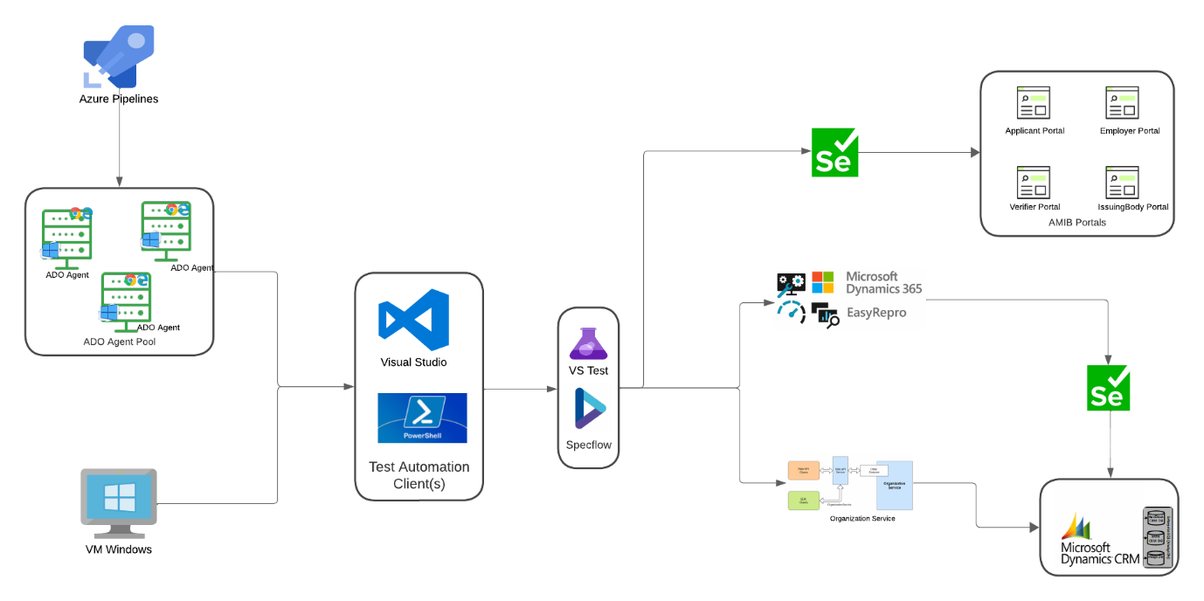

* Open Source Technologies
* Solution to test most of the testing interface landscape
* Behaviour Driven Development (BDD) technique
* The Visual Studio Test Platform with the MS Test V2 test framework
* Fits into current Azure DevOps lifecycle and can be seamlessly migrated to any other CI/CD tool stack

# Approach

## BDD Tests

The idea with acceptance testing is to write tests (or behaviour specifications) that describe the behaviour of your software in a language which is not code but is more precise than Standard English. Doing this allows people who are not software engineers, but have knowledge of the requirements to write the scenarios that make up ATs (acceptance tests).

Those tests later can be run using a parser which will allow to match language blocks to functions in the programming language of our choice.

## 4.2 Example

Following a template and language constructs used by the Cucumber/Specflow/Gherkin parser.

Scenario: User successfully creates a LinkedIn account

Given John is on the LinkedIn account registration page

When he submits all required mandatory registration details

Then a LinkedIn account is created successfully for Adam

## 4.3 External Resources

<https://en.wikipedia.org/wiki/Behavior-driven_development>

<https://specflow.org/>

<https://www.selenium.dev/>

<https://github.com/microsoft/EasyRepro>

# Test Project Structure

## Naming Convention

* All feature files which contain test scenarios should be under the Tests folder of the solution(s)
* All steps should be under the steps folder
* All page object classed should be under Pages folder
* Test data files should be under TestData folder
* Infra folder contains framework components for Selenium Web driver, Easy-Repro etc.,
* Extensions folder contains C# extension files for Selenium Web driver, Easy-Repro and Expected Conditions etc.,
* Every class, method, feature file(s) should be self-descriptive and human readable
* Config folder contains all environments urls, crm urls and helper classed to access to url configs from the test steps.
* A .runsettings file(s) are used to configure how tests are being run. They are also used to configure tests that are run from the command line, IDE or in a Azure DevOps Test plans and release workflows.

## Source Code Repository

As a standard process to support versioning and easy access of automation solutions, the solutions is created at the same level as the other application repos such as MS CRM and Dot Net Portals etc.,

This might be slightly different for the solutions which are housed in the application repository where it’s recommended to add the solution under Test folder.

## Test Solution Dependencies/Utilities

|  |  |
| --- | --- |
| BDD | Specflow |
| Unit testing framework | MS Test |
| Web Applications | Selenium |
| MS Crm | Easy Repro |
| Assertion framework | Fluent Assertions |

# Tools and Development Language

## Development Environment (IDE)

Visual Studio Enterprise/Professional edition. At the time of writing this document Specflow based BDD tests are successfully created and maintained by VS 2019, 2022 versions.

## Third Party Libraries

Easy Repro – Easy repro is an automated UI testing framework developed by Microsoft for Dynamics 365 applications. It provides a set of commands that make setting up UI testing quickly and easy, covering core CRM commands that end users would perform on a typical task. The framework is built on the open-source Selenium Web driver and is available on GitHub.

Easy Repro covers a wide range of Dynamics 365 functionalities, including entity forms, grids, and sub grids, which ensures comprehensive testing coverage.

## Development Language

Majority of automation code will be developed in C# (C SHARP) language, but this does not limit for using other languages like JavaScript etc., where required which is embedded into testing framework to perform applications specific actions.

Example: If some browser specific actions (setting/un-setting web element focus) required to inject some JavaScript code, which will be embedded into C# function and then feed into browser to perform action via Selenium/Web driver.

# BCS and AMIB Test Automation Pre-requisites

## Azure DevOps Server

BCS and AMIB Scrum teams utilizes on-premises version of Azure DevOps for software development. Azure DevOps server provides suite of tools for software development, including version control, project management, automated builds, testing, and release management.

AMIB - <https://devops.bcz.gov.au/ASR/Issuing%20Body%20System>

BCS - <https://devops.bcz.gov.au/ASR/Auscheck%20Redevelopment>

Access: Reach out to scrum master of AMIB and BCS teams to get access to Azure DevOps. Alternatively TWS Admin team (Brady SCHOO) can also be reached who can provide required access.

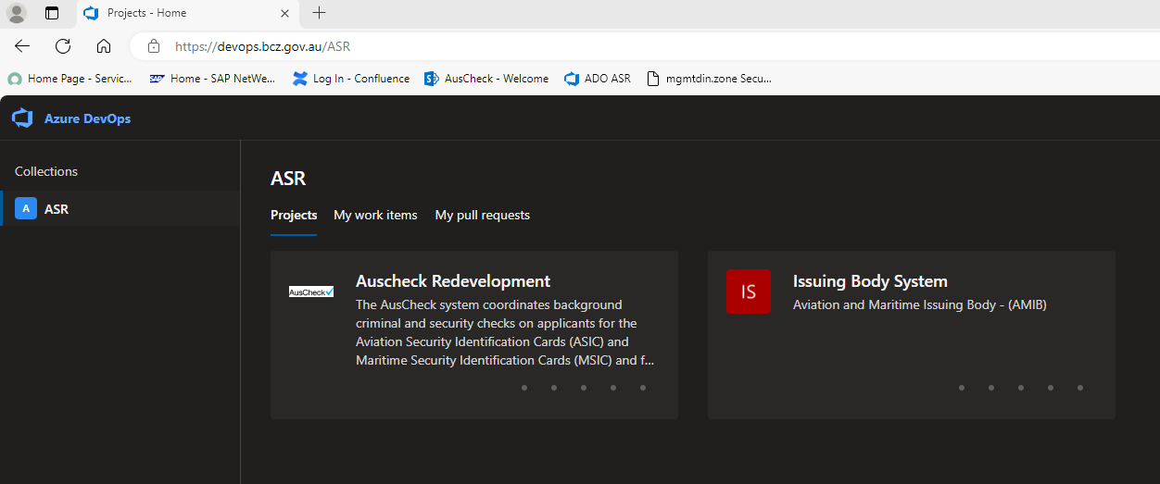

## Portals and Crm Urls

BCS

E6 Portal: <https://e6-auscheck-external-ib-portal.dinnp.bcz.gov.au/>

E7 Portal: <https://e7-portal.auscheck.gov.au/>

E6 Crm: <https://auscheck-test2.dinnp.bcz.gov.au/>

E7 Crm: <https://auscheck-uat.dinstage.bcz.gov.au>

AMIB

E6 Portal: <https://e6b-amib-external-portal.dinnp.bcz.gov.au>

E6 Portal: <https://uat-asicmsic.homeaffairs.gov.au>

E6 Crm: <https://amib-test2.dinnp.bcz.gov.au/>

E7 Crm: <https://auscheck-uat.dinstage.bcz.gov.au/>

## Security Groups & Network Access

### ROLp-TWSDevelopers:

TWS Virtual Machines are utilised for Test Automation script development and executions. To access those VM machines supported by TWS team, Security group “ROLp-TWSDevelopers” need to be assigned to DINNP Admin account.

The following Connection Service Request can used to request one if not requested while requesting DINNP Admin account.

**Administration of Standard Active Directory Security Groups Access Management (Create/Update/Remove)**

**Note**: TWS Admin team have notified that going forward existing TWS VM machines will not be supported by their team and requested to log new “**Server Build Service Request**” from connected services and liaise with Brady SCHOO.

### Extension Attribute 13:

Active Directory group extension attribute 13 to be enabled to access the AusCheck and AMIB CRM applications.

The following Connection Service Request can used to request one if not requested while requesting DINNP Admin and DINSTAGE account (s).

**Admin accounts and/or Service accounts access to CRM applications**

**Note**: Once Extension 13 attribute is applied then request CRM Developer from AusCheck team (BCS and AMIB) to provide access to CRM instances as required.

### Network Access:

Test Automation developer should have DINNP Admin, DINSTAGE and MGMTDIN accounts.

Connected Services Request - **Windows Privileged User Account Management**

### Visual Studio and GIT:

Install Visual Studio Enterprise/Professional edition directly from Microsoft and once installed apply product key in order to use it as licenced version.

Its recommended to run Visual Studio in admin mode, failing may sometimes build errors which may occur with access privileges of deleting or updating solutions file(s)/folder(s).

Note: Check Automation Manager for Visual Studio Subscription provisioning. Upon login to VS Subscription, there will be option to generate product keys for many MS Licenced software.

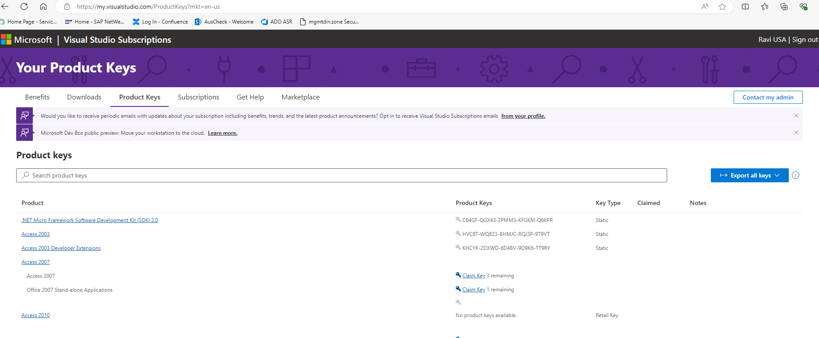

Visual Studio Specflow Extension:

Once Visual Studio is installed and operating as expected then install as show below and once extension is install.

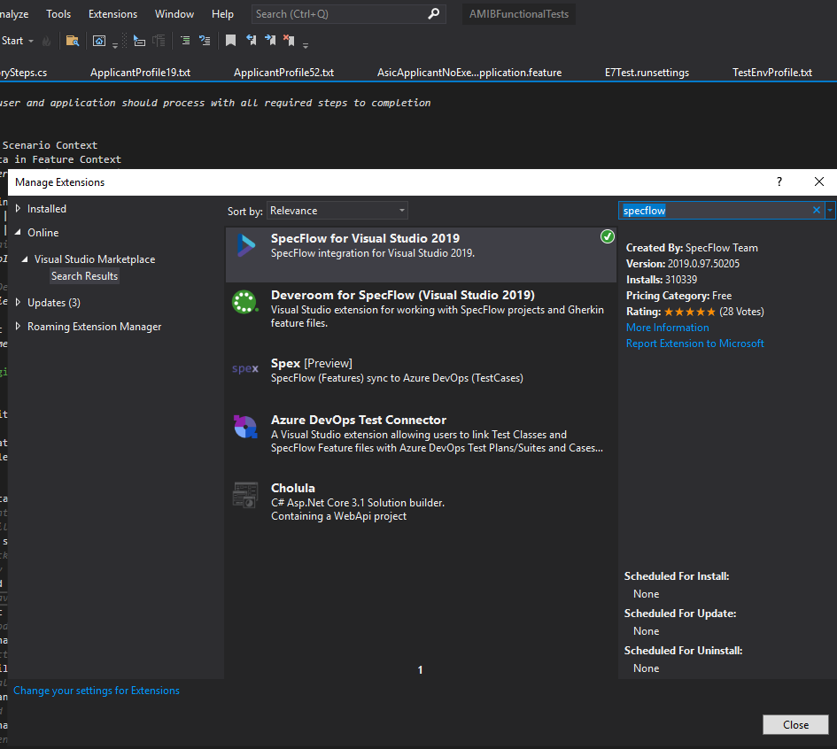

Upon starting VS again all the feature files should be display with Specflow theme as follows

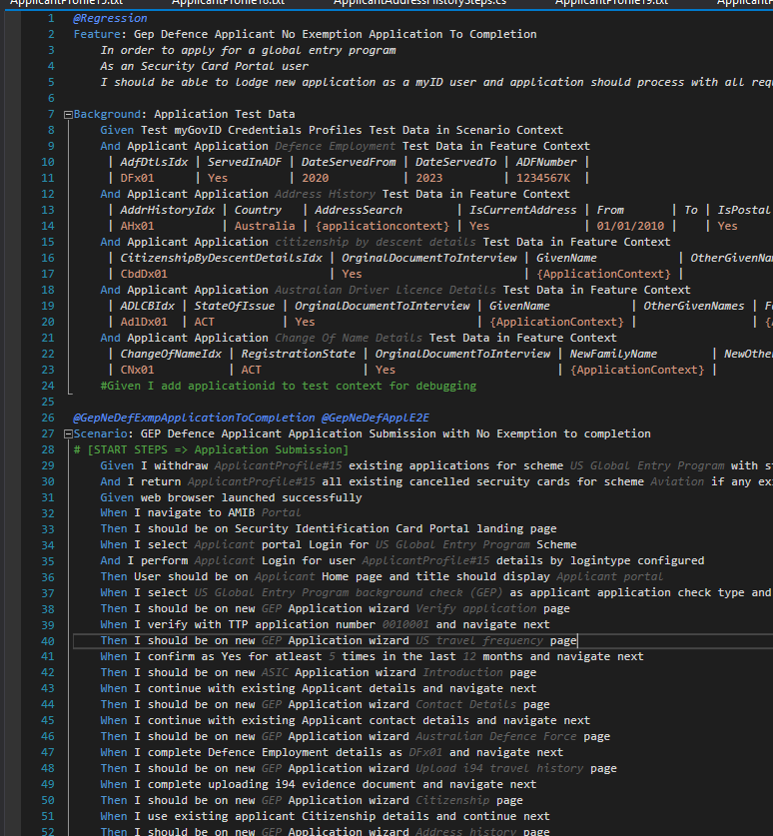

### ADO Code Repo Checkout:

ADO GIT repos houses both BCS and AMIB Test Automation Solutions as follows.

BCS

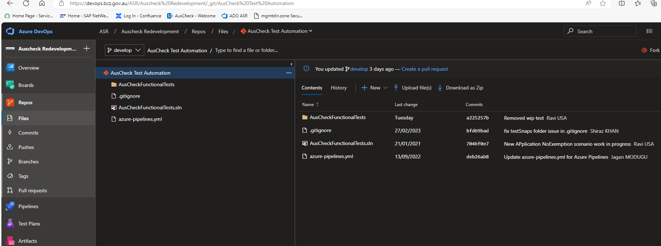

AMIB

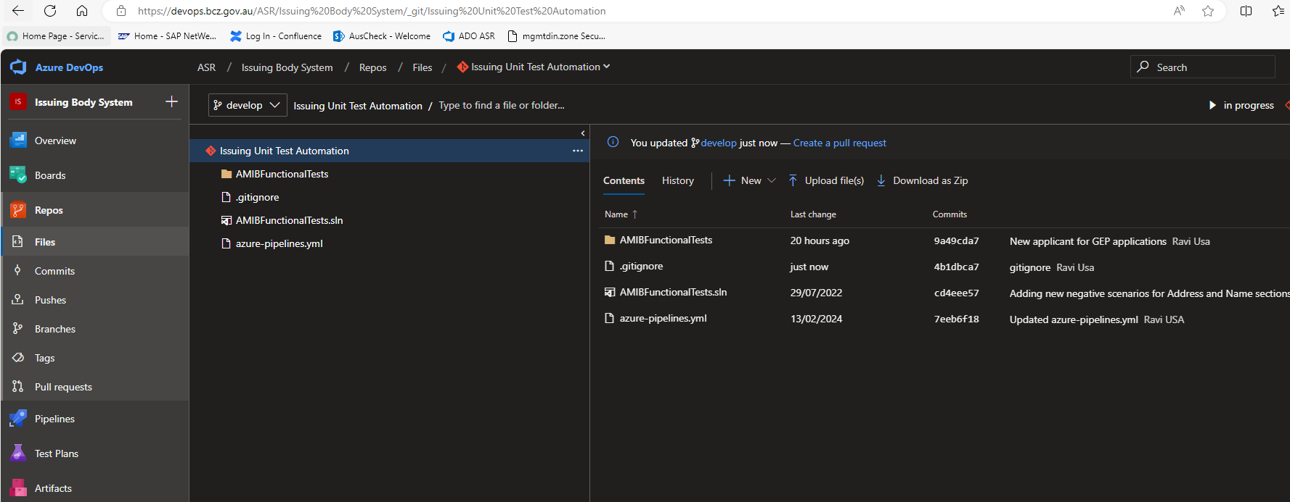

**Using Personal Access Token (PAT) for git auth:**

1. Firstly you need to create a new personal access token within Azure DevOps, for more information on how to do this see the [Authenticate access with personal access tokens](https://docs.microsoft.com/en-us/azure/devops/organizations/accounts/use-personal-access-tokens-to-authenticate?view=azure-devops&tabs=preview-page) article. Log in <https://dev.azure.com>

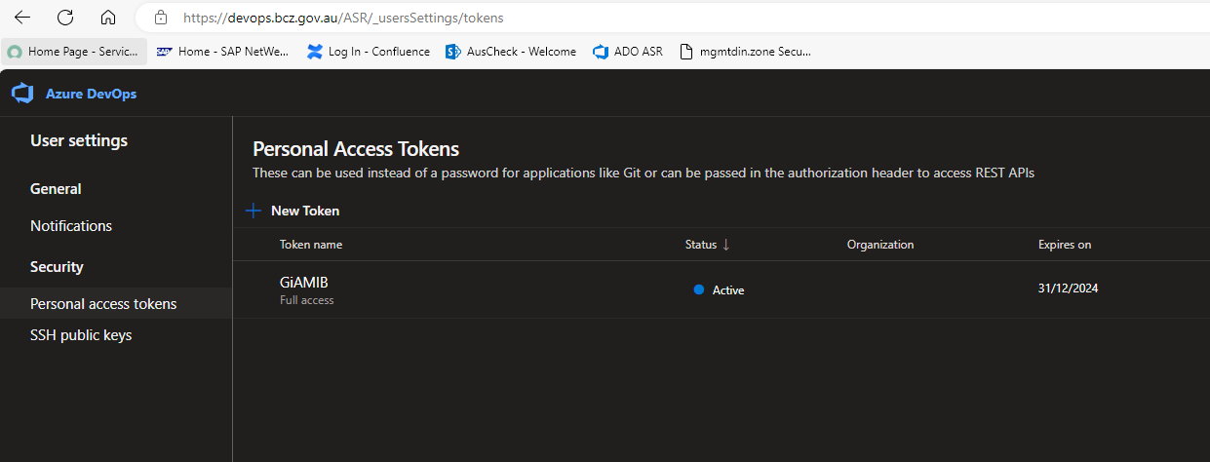

1. Once you have a Personal Access Token from DevOps, you need to encode it as base64 before it will be valid in the configuration. <Encoded User token> represents a base64 encoded version of your PAT in the format: "<devops access account username>:<PAT>"
   * I generally recommend just using this site to perform the encode <https://www.base64encode.org/> but you can use a local base64 encoder in your environment of choice (PowerShell/JS/.Net etc).
2. Set the authorisation header in your user profile.
   * git config --global http.extraheader "AUTHORIZATION: Basic <Encoded User token>"
   * Alternatively, you can append the authorisation header to individual git operations, this is not required if the header has been configured at the --global level.
     + git -c http.extraheader="AUTHORIZATION: Basic <BASE64_TOKEN_CREATED_FROM_PAT>" clone <https://devops.bcz.gov.au/ASR/Auscheck%20Redevelopment/_git/AusCheck%20Test%20Automation> "AusCheck Test Automation"
3. Once repo is checked out, use git commands to switch to required git branch.
4. As a practice, develop branch is used current release cycle for development and integration and once the release is completed promote the code to master branch.

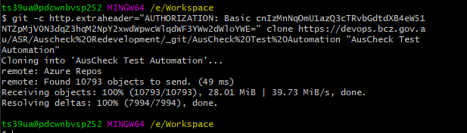

### Windows Credentials:

Configure the VM machine (s) with proxy details as follows,

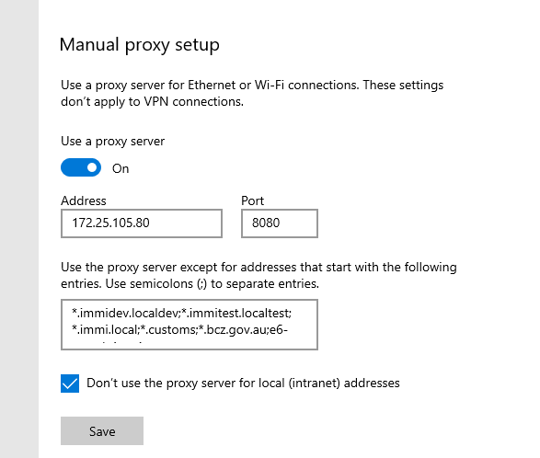

Bypass Proxy List: **\*.immidev.localdev;*.immitest.localtest;*.immi.local;*.customs;*.bcz.gov.au;e6-portals.immi.gov.au**

Windows Credentials: Add windows with two entries, one with just proxy server and the other with proxy and its port as follows,

172.25.105.80

172.25.105.80:8080

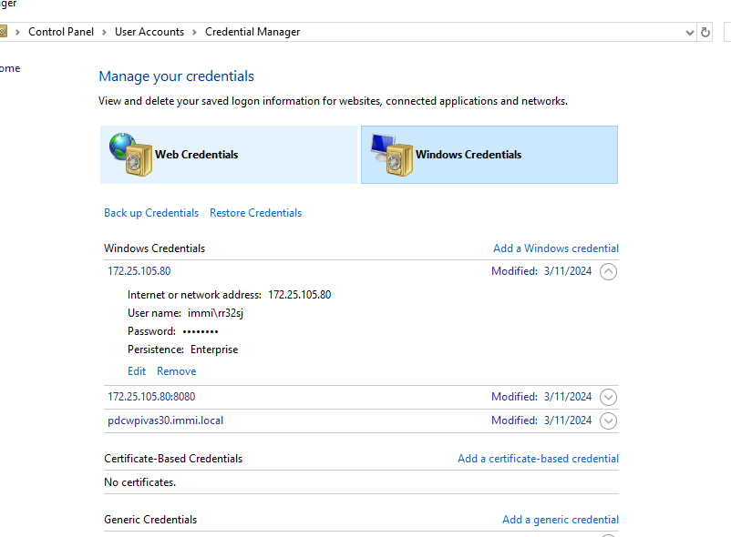

Use your immi account as it is the account which has internet access. This is required as the AMIB and BCS portals use myID (formerly myGovID) for authentication and the request goes over internet to ATO server for authentication and routing back once successful.

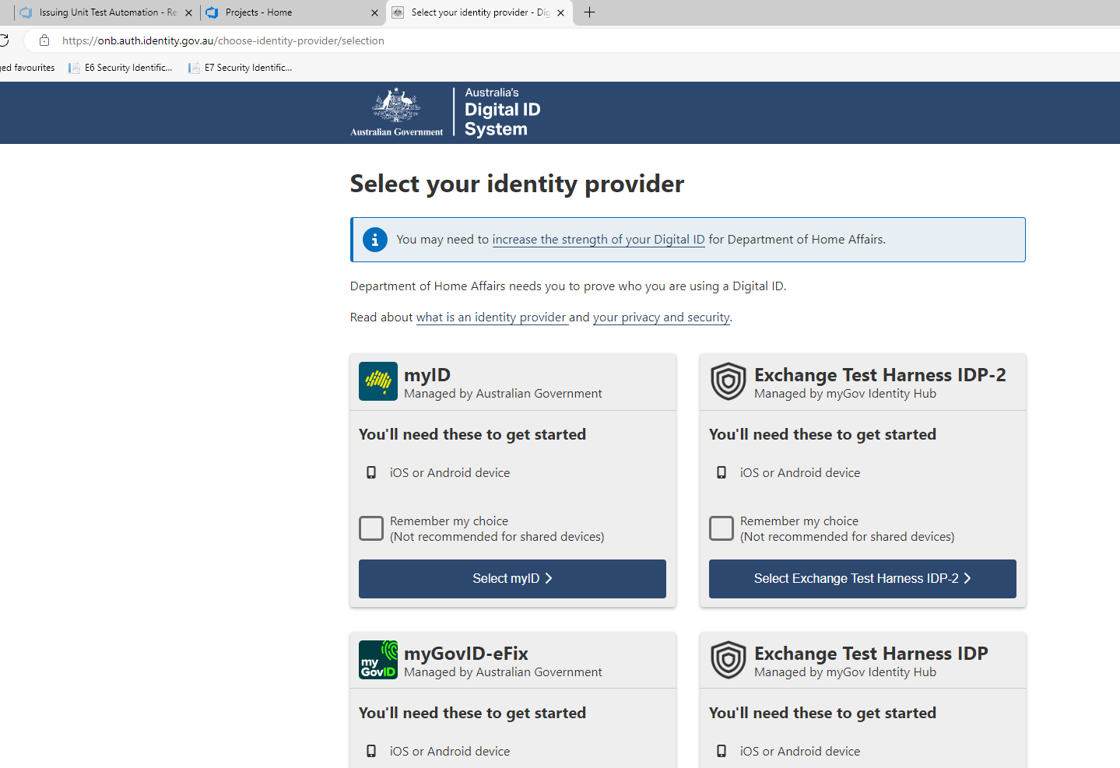

## Test Solution Structure

* app.config: app config contains all project related properties, app settings etc.

1. BCS

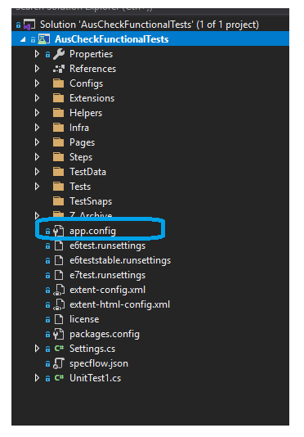

1. AMIB

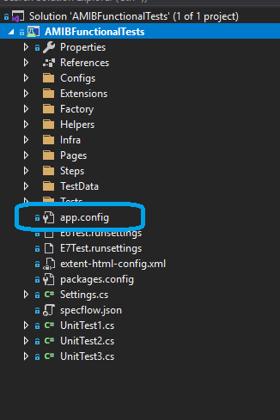

* Configs: The Config folder hosts test environment profile url’s details and utility class to access the config items

1. BCS

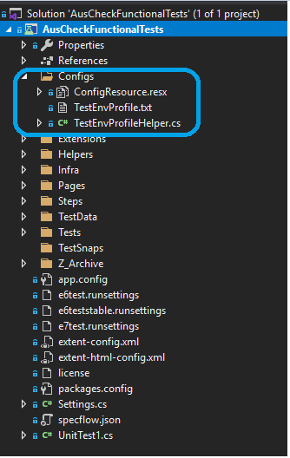

1. AMIB

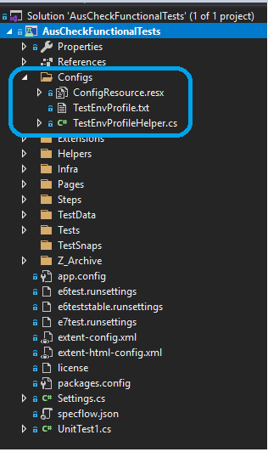

* .runsettings: A .runsettings file can be used to configure how unit tests are being run. Runsettings files can be used to configure tests that are run from the command line, from the IDE, or in a build workflow using Azure Test Plans or Azure DevOps Server (formerly known as Team Foundation Server (TFS)).

1. BCS

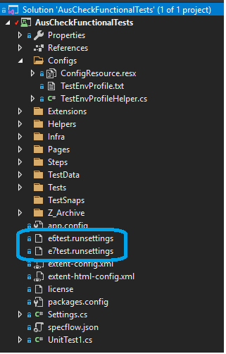

1. AMIB

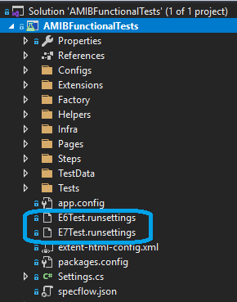

* AMIB User Profiles: Applicant, Employer, Verifier and Issuing Body User

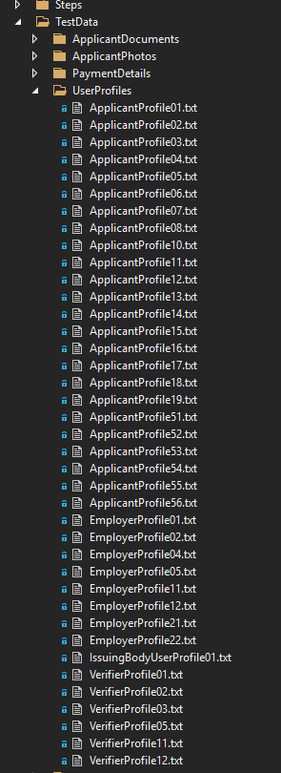

## BCS Build and Release Pipelines

BCS build pipeline continuously builds Test Automation repo for every git remote push to all the branches in the repo.

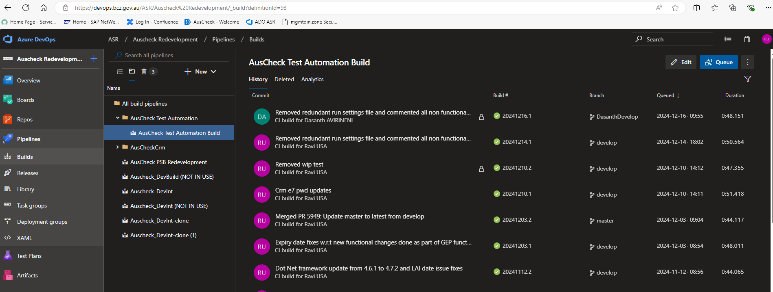

Build pipeline is an standard pipeline defined in yml structure as follows which have Test Automation Pool with machine demands details, Steps with nuget restore, build solution, copy and publish files to drop location as follows.

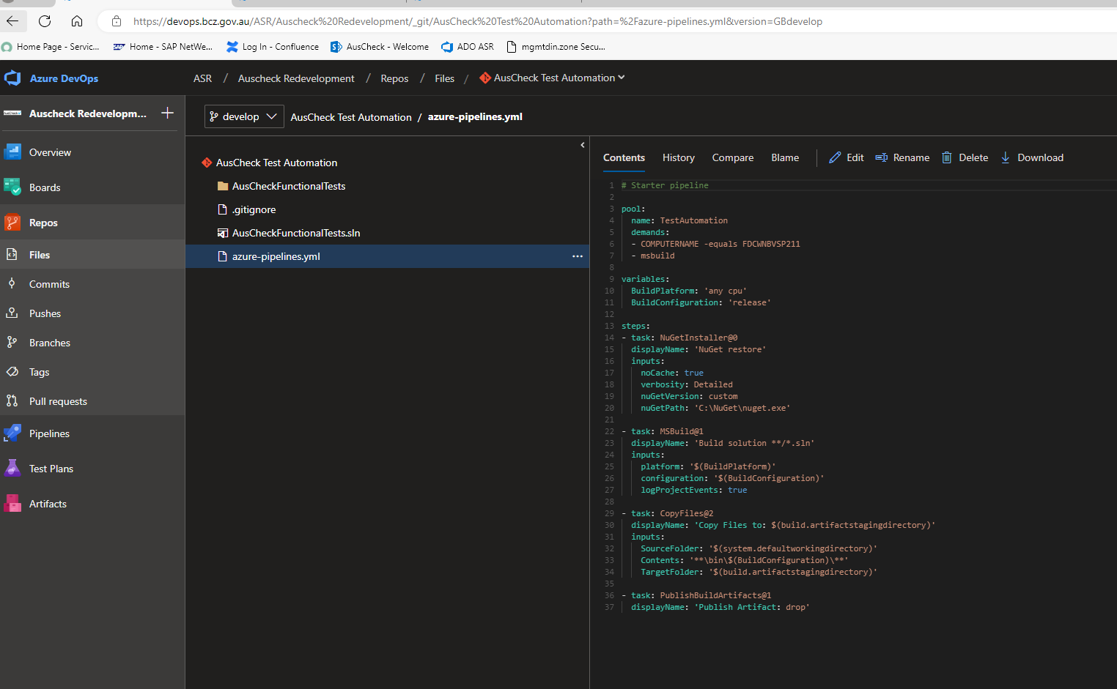

Successful build logs –

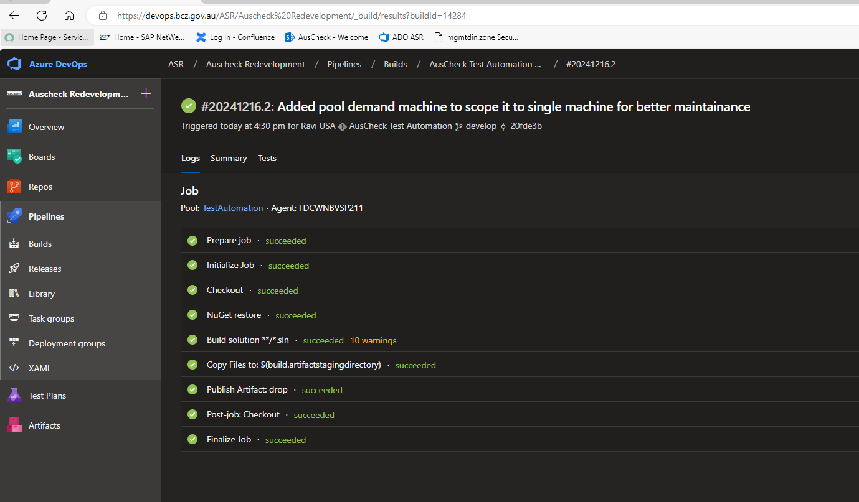

All build execution should send email notifications which will be as follows.

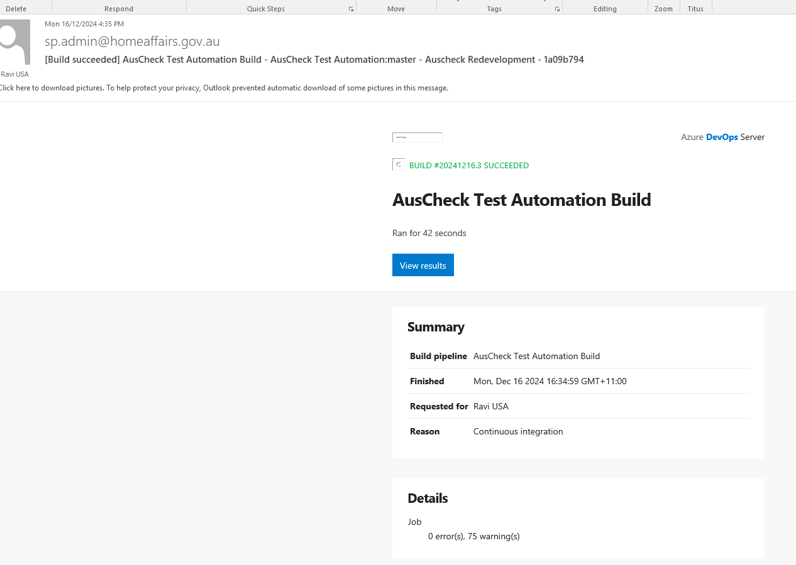

**Release Pipelines:**

AusCheck BCS project has been configure two distinct pipelines to serve test execution for a single or group of tests which are identified by the test tags and run tests from directly via Test Hub.

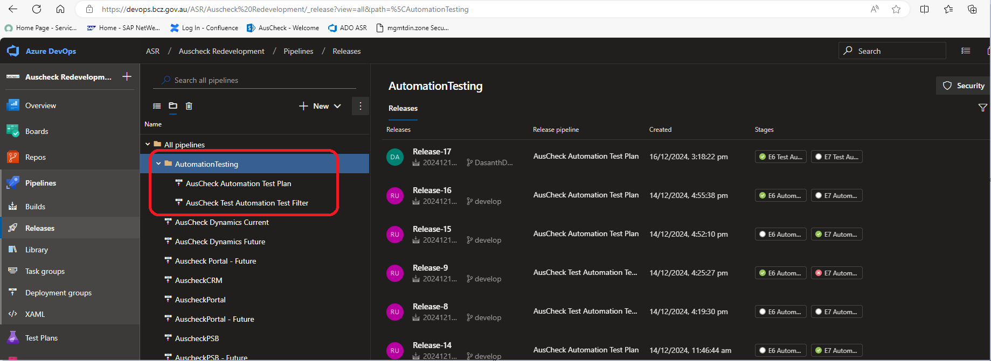

**AucCheck Automation Test Plan** – This pipeline is configured to run tests directly from Test Hub. Details of using this pipeline is documents in Test Execution section of this document. Pipeline serve to run tests in e6 and e7 stage environments respectively as follows:

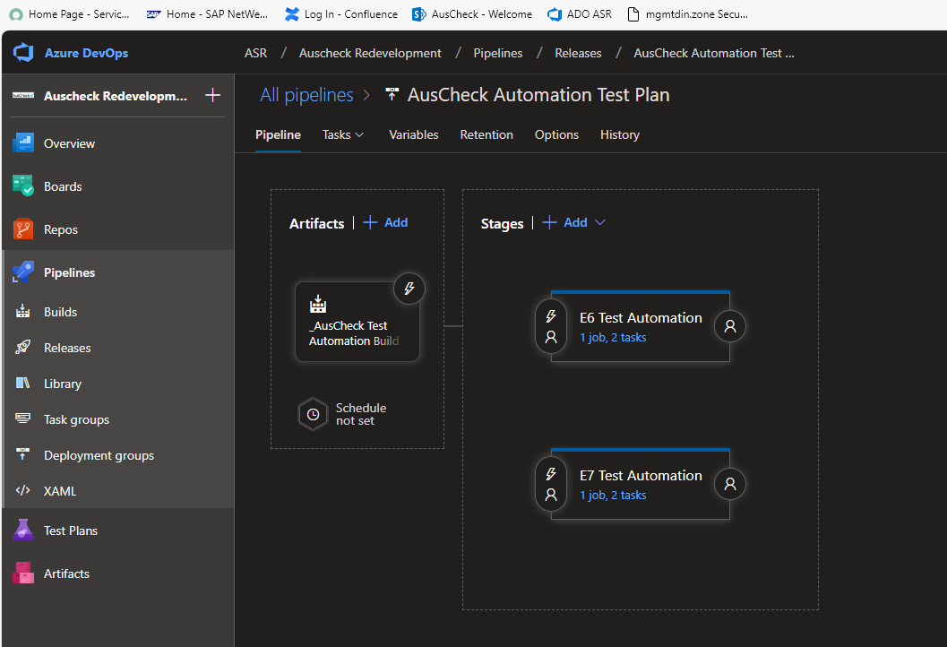

Some pipeline executions results for reference:

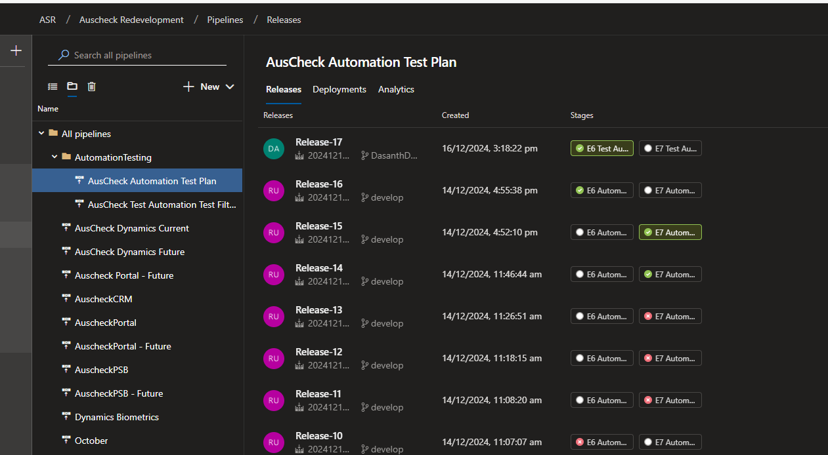

**AusCheck Test Automation Test Filter** – Test filter pipeline is configured to run tests on demand which satisfies with filter conditions defined in the filter variable. Pipeline serve to run tests in e6 and e7 stage environments respectively as follows:

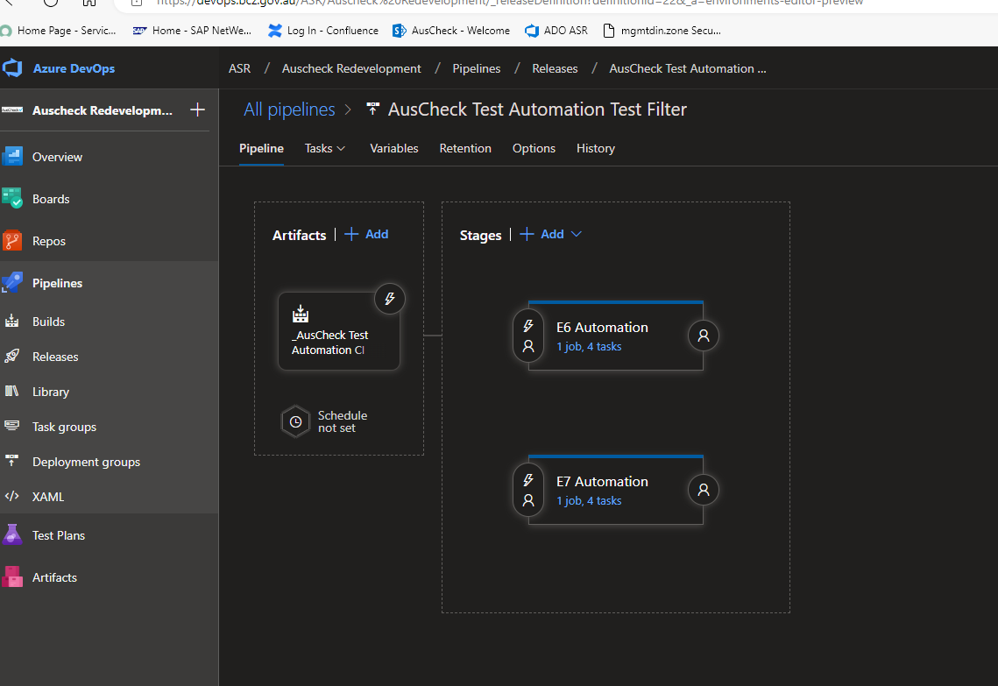

Test filter category defined in VsTest definition as follows

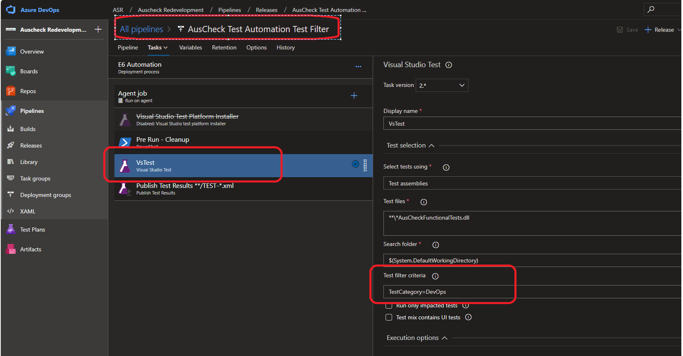

Some pipeline executions results for reference:

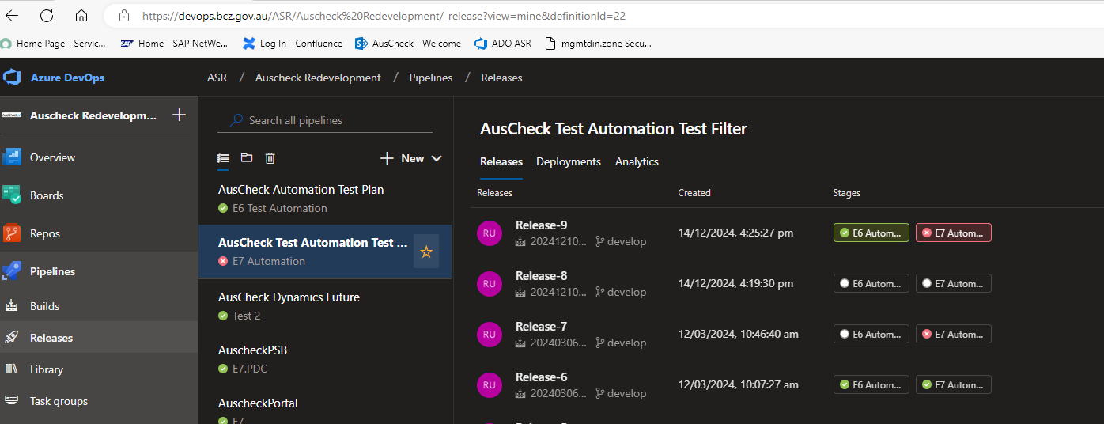

## AMIB Build and Release Pipelines

AMIB build pipeline continuously builds Test Automation repo for every git remote push to only develop and master branches as the time of writing this document. This can be extended as required as per the needs of the project and approach.

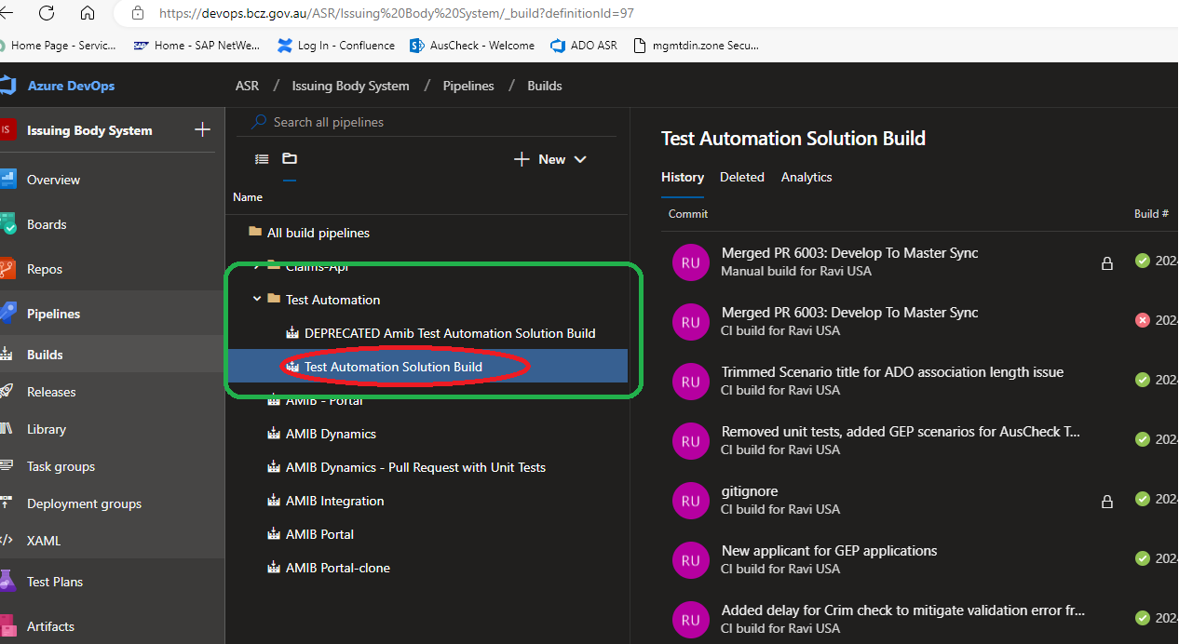

Note: Deprecated pipeline can be deleted in the near future as that configuration is classic way of defining pipeline and not used any more.

Build pipeline is an standard pipeline defined in yml structure as follows which have Test Automation Pool with machine demands details, Steps with nuget restore, build solution, copy and publish files to drop location as follows.

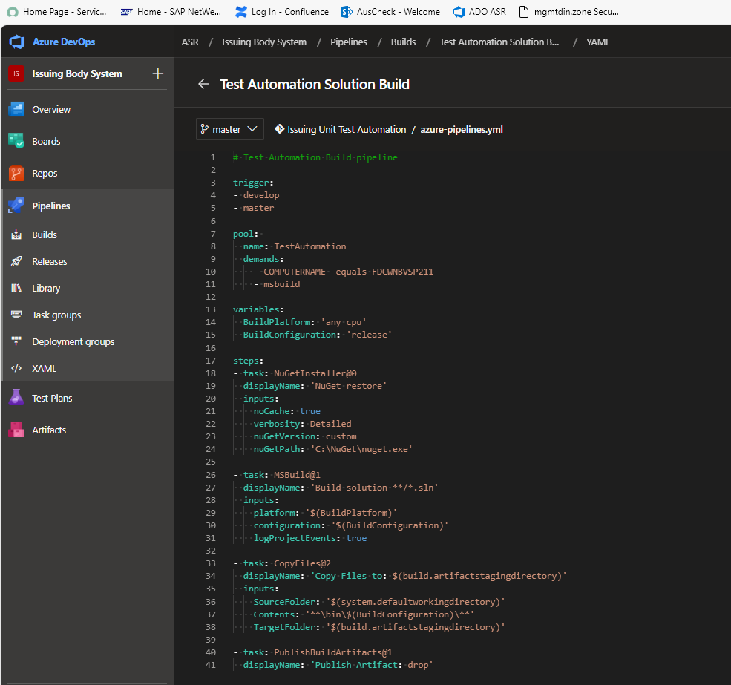

Successful build logs –

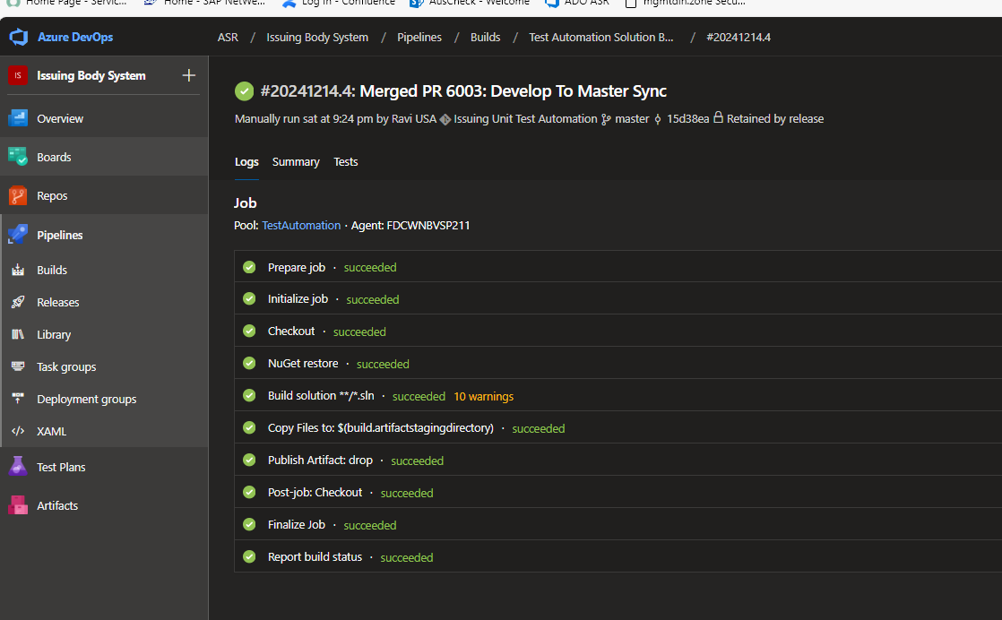

**Release Pipelines:**

AusCheck AMIB project has been configure two distinct pipelines to serve test execution for a single or group of tests which are identified by the test tags and run tests from directly via Test Hub.

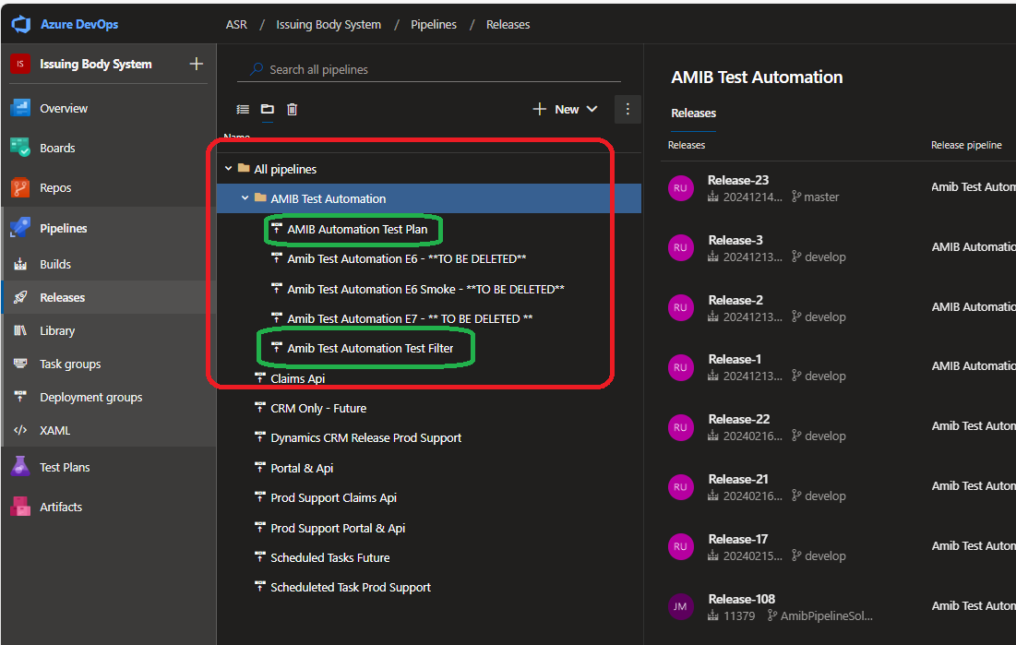

Note: Deprecated pipeline are there just for reference and should be details as those pipeline tests are all poorly implemented hence removed from the suite. Please plan to delete those deprecated pipelines in the near future.

**AMIB Automation Test Plan** – This pipeline is configured to run tests directly from Test Hub. Details of using this pipeline is documents in Test Execution section of this document. Pipeline serve to run tests in e6 and e7 stage environments respectively as follows:

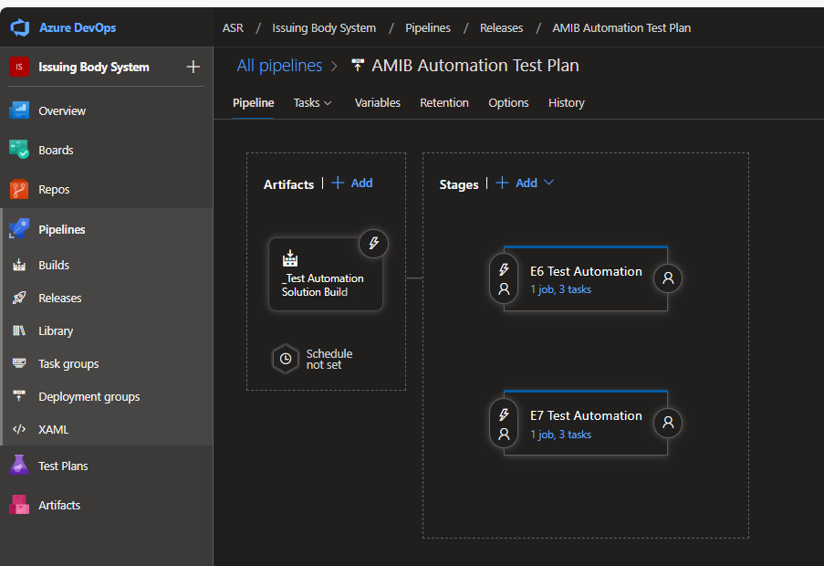

Some pipeline executions results for reference:

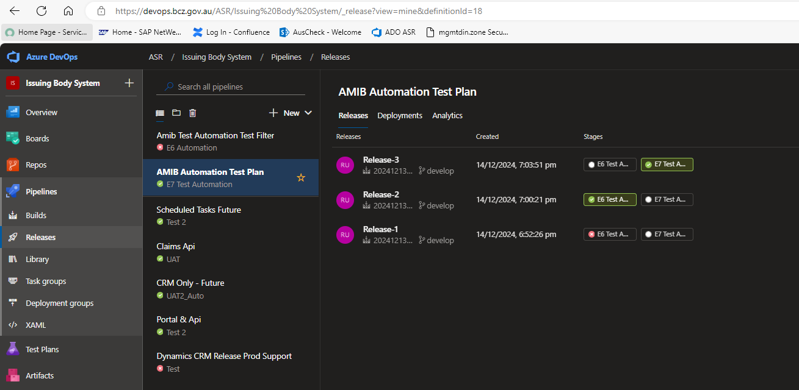

**AMIB Test Automation Test Filter** – Test filter pipeline is configured to run tests on demand which satisfies with filter conditions defined in the filter variable. Pipeline serve to run tests in e6 and e7 stage environments respectively as follows:

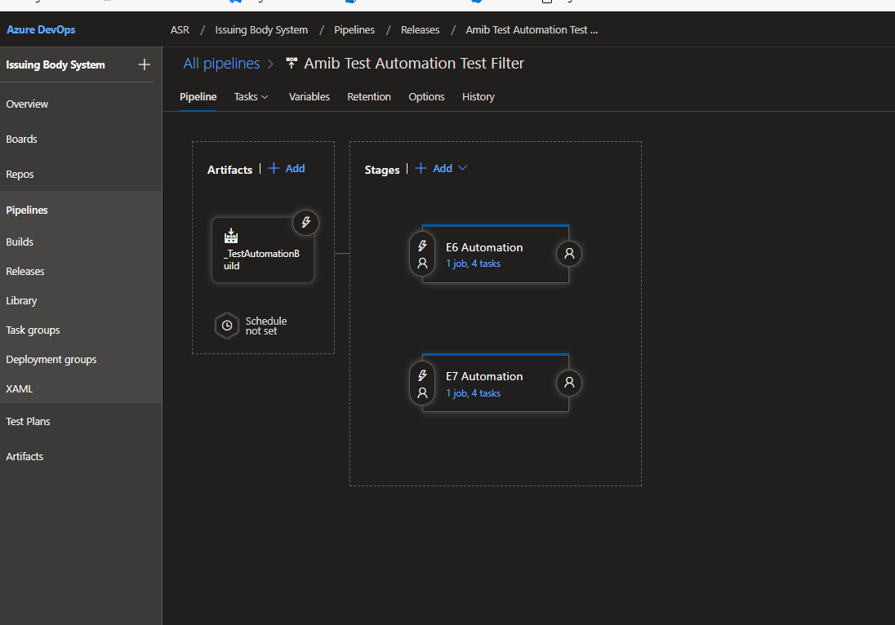

Test filter category defined in VsTest definition as follows

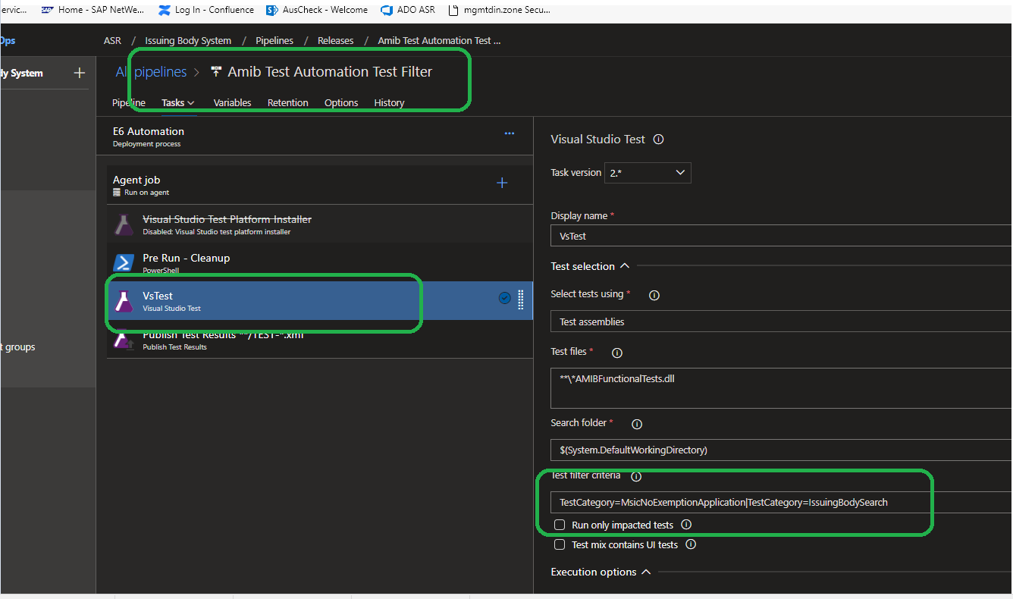

TestCategory=MsicNoExemptionApplication|TestCategory=IssuingBodySearch

Where **MsicNoExemptionApplication**  and **IssuingBodySearch** are test tags.

Some pipeline executions results for reference:

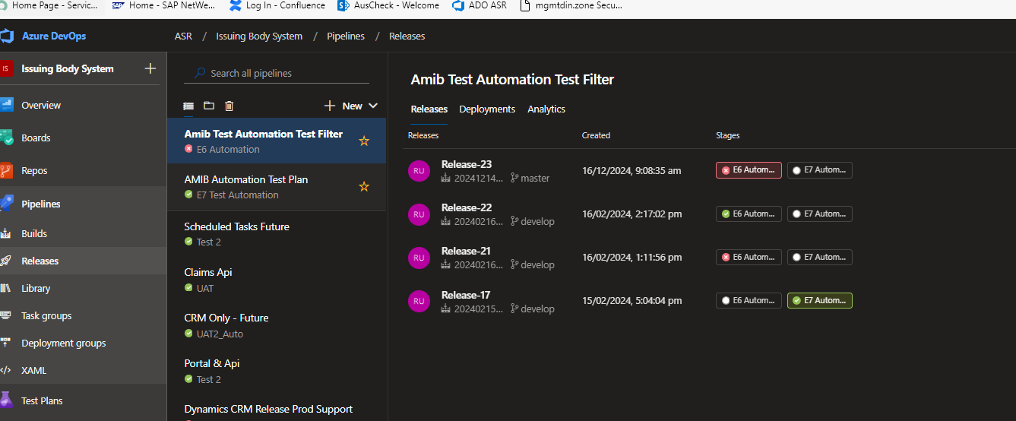

## Test Execution

AusCheck BCS and AMIB projects automation tests can be executed by different ways as depicted in the Test Automation Solution Diagram. Please refer to section 4 in this document.

Test Execution Options:

* Visual Studio Test Explorer
* Command Line/PowerShell Window
* Release Pipelines

Note: Before running any test please check Symantec Protection is disable in the machine. Please check Appendix details (end of this document) for more details on **Symantec Antivirus Protection.**

### Visual Studio Test Explorer

The following details are same for both AusCheck BCS and AMIB Test Automation solutions.

* Load the test automation solution repo in visual studio 2019/2022.
* Restore project nuget packages

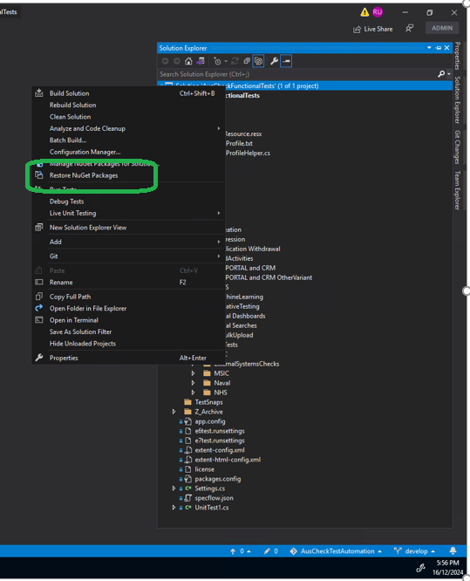

* Build the solution/project via build menu or Ctrl + Shift + B command.
* Build the solution/project via build menu or Ctrl + Shift + B command.

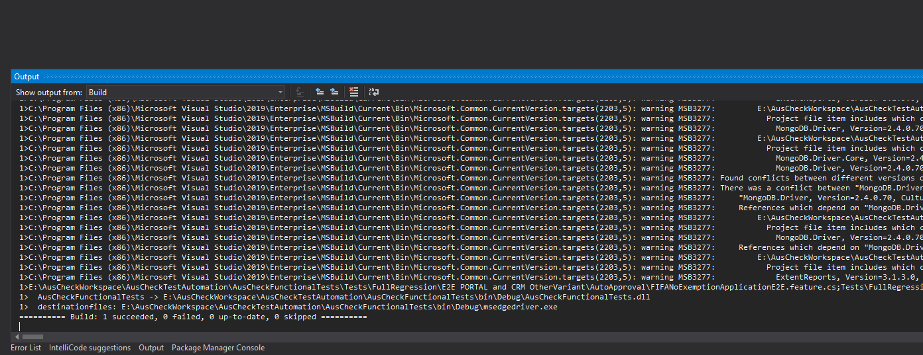

* Open Test Explorer which should automatically detect all tests that are ready to be executed.

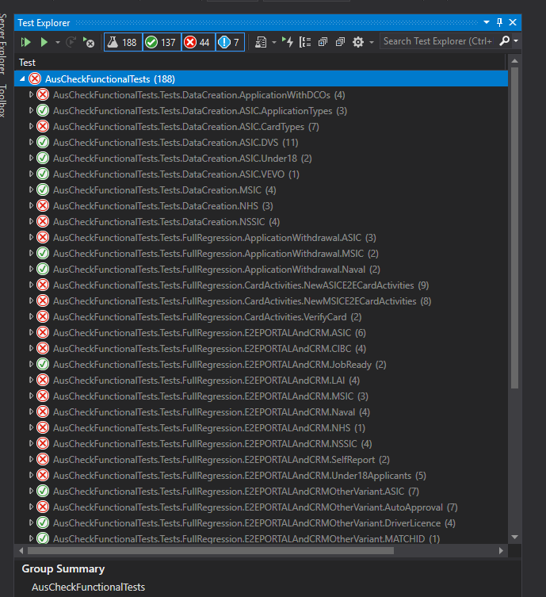

Before selecting a test (s) select which environment the test as to be executed as follows for e6 and e7 run setting selection.

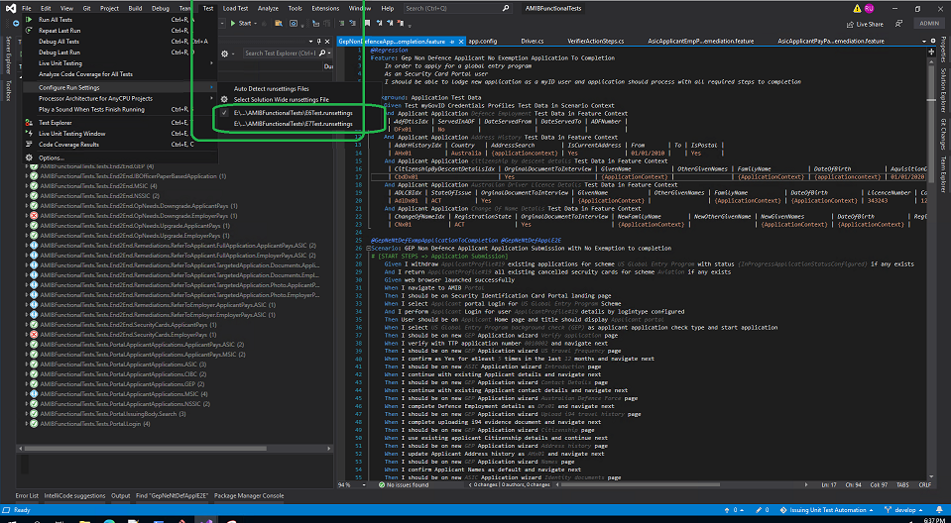

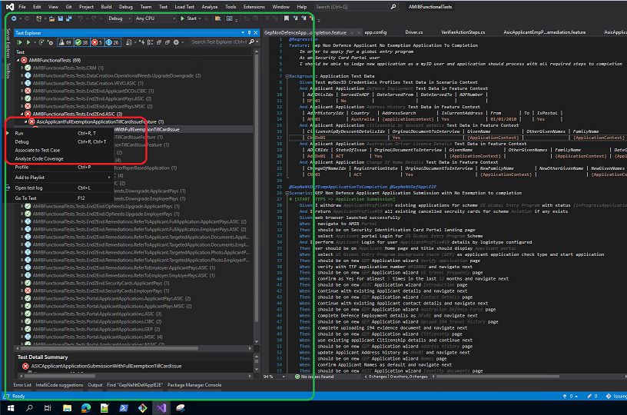

Once the test execution is competed, if failed check the stack trace and correct screen shot from the test run log displayed at the bottom of the test explorer as follows

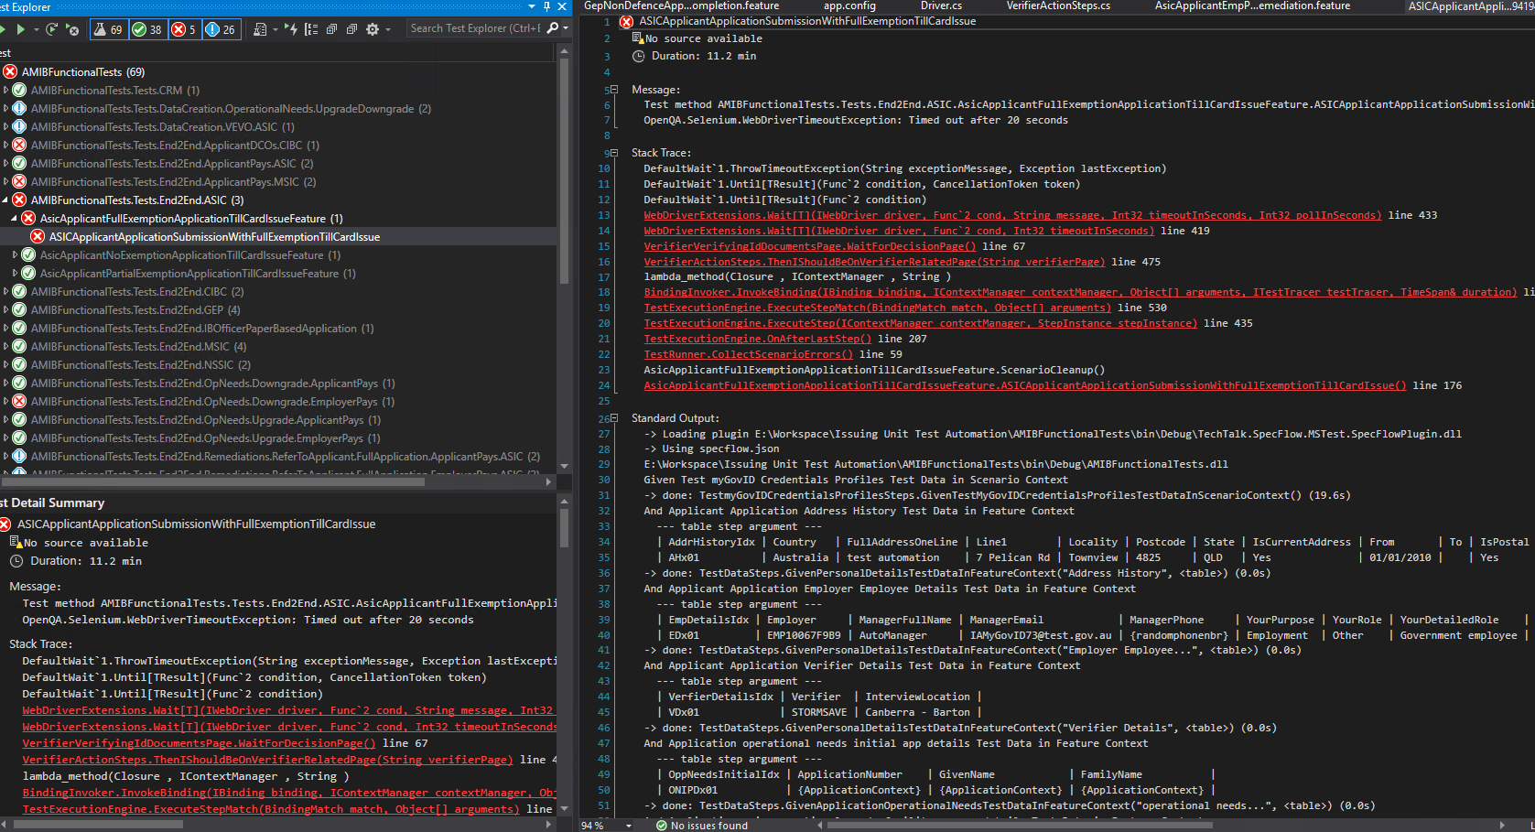

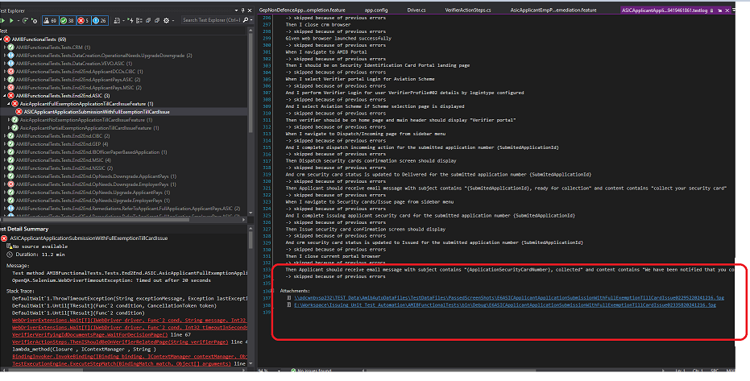

AMIB

Before selecting a test (s) select which environment the test as to be executed as follows for e6 and e7 run setting selection.

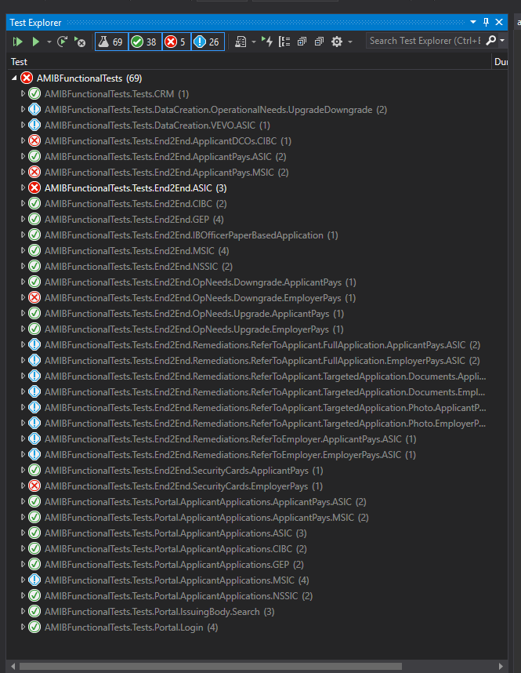

AMIB Tests from test explorer will be same as BCS project screen and test environment settings. Please correlate the above screen to the corresponding screen in AMIB project and they will be self-explanatory.

### Command line

Tests can also be executed via powershell or Command line interfaces based on test tags as follows.

Open command line window or Powershell window and change to directory where the solution build artefacts are generated by default. Here in this case the solution build generates all solution artefacts to “**E:\Workspace\Issuing Unit Test Automation\AMIBFunctionalTests\bin\Debug**” directory.

Command:

vstest.console.exe AMIBFunctionalTests.dll /Settings:E7Test.runsettings /InIsolation /TestCaseFilter:"TestCategory=**GepNeNtDefApplE2E**" /Logger:"trx;LogFileName=GepNeNtDefApplE2E_E7R4_9.trx"

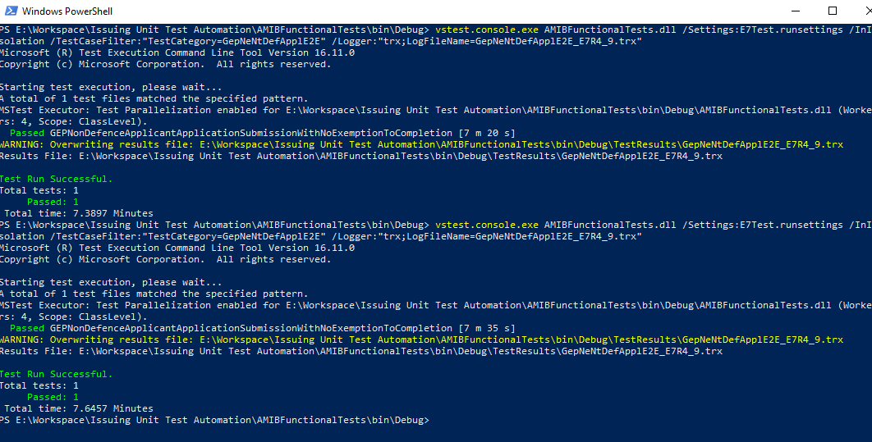

Note: **GepNeNtDefApplE2E**  - Test Tag as follows

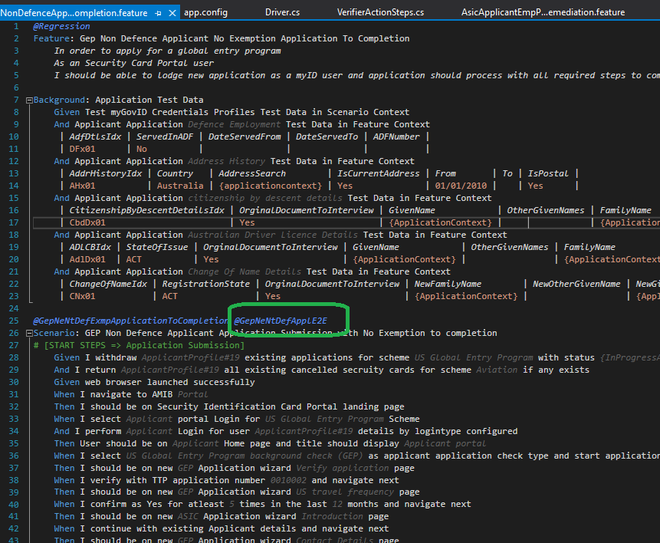

Parallelization:

Test suite support running tests in parallel. The following config section in runsetting define and enables the parallelisation and number of parallel depends on the machine where the tests are being executed.

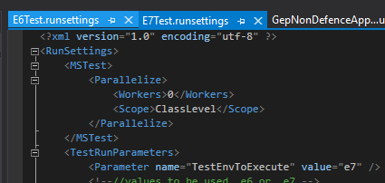

Run the tests at class level as these tests are structured as 1 test for each feature file to support parallelization.

If we comment/remove the parallelize node from the runsettings then each and every tests in the execution group will run in sequential one after other.

For more details on parallelization follow the below link.

Reference - <https://learn.microsoft.com/en-us/visualstudio/test/vstest-console-options?view=vs-2022>

### Release Pipelines

ADO agents: TestAutomation Agent pool have 4 machines configured as agents. For any issues with the agents please reach out to Brady SCHOO.

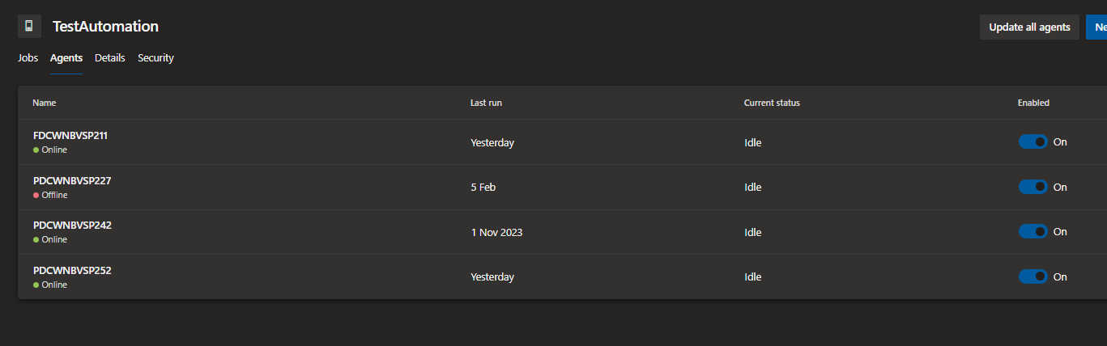

**AMIB Automation Test Hub Test Plan:**

Tests can be directly executed from Test Hub Test Plan as follows.

<https://devops.bcz.gov.au/ASR/Issuing%20Body%20System/_testManagement>

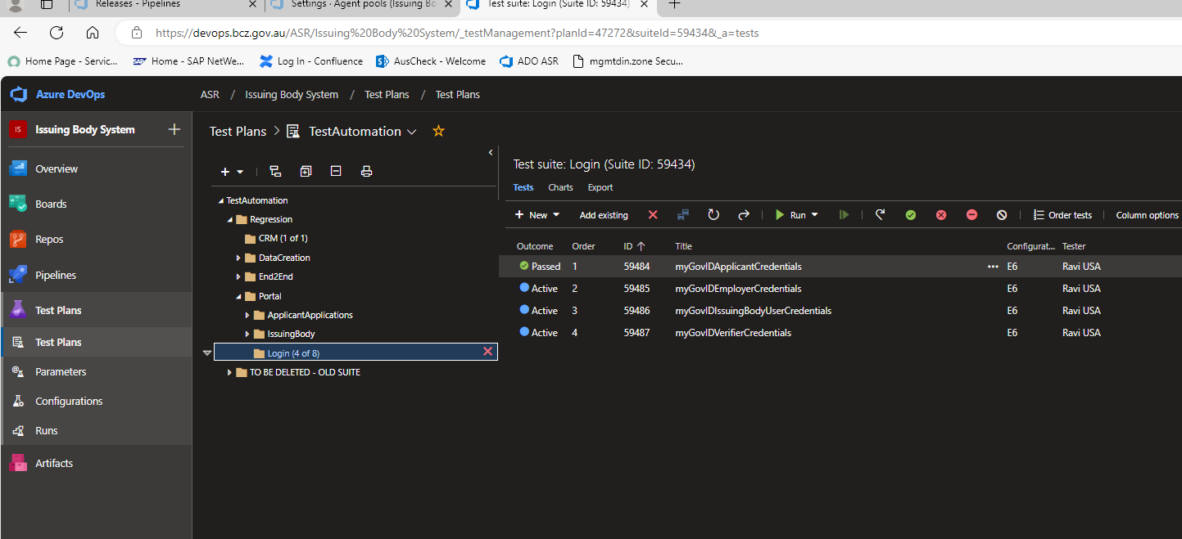

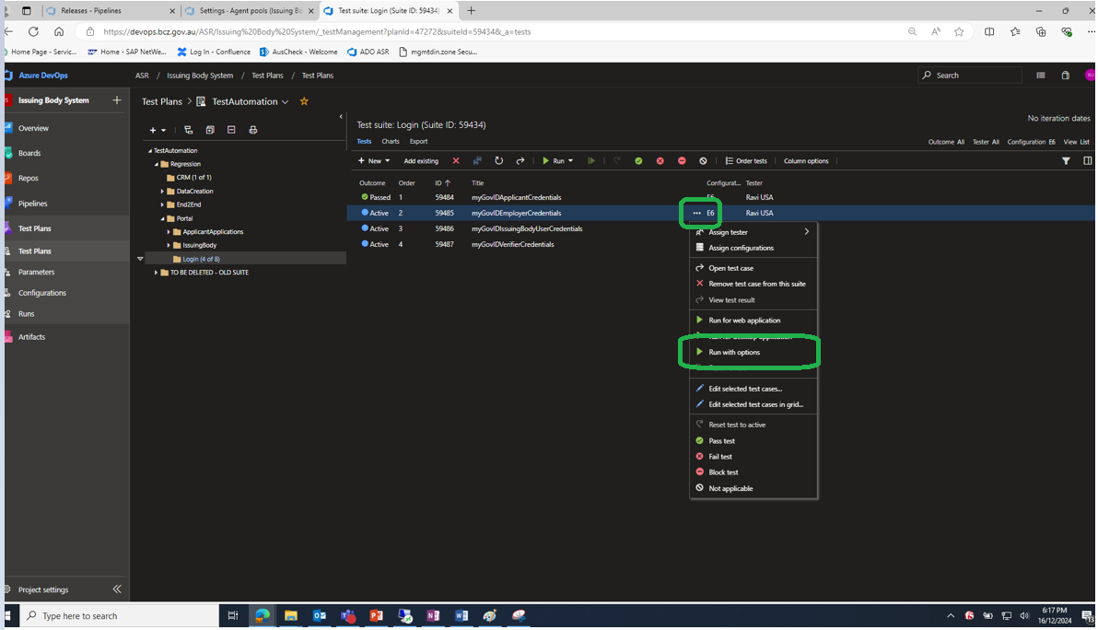

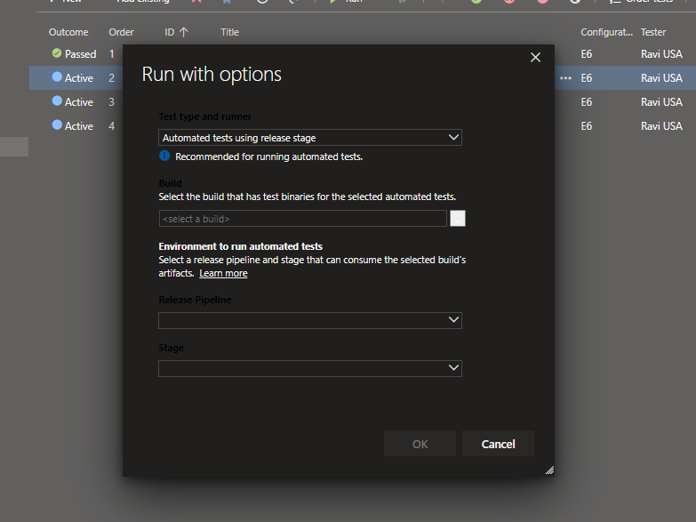

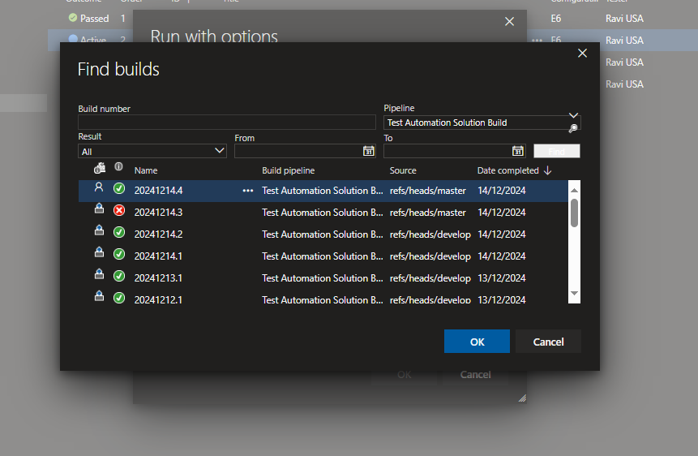

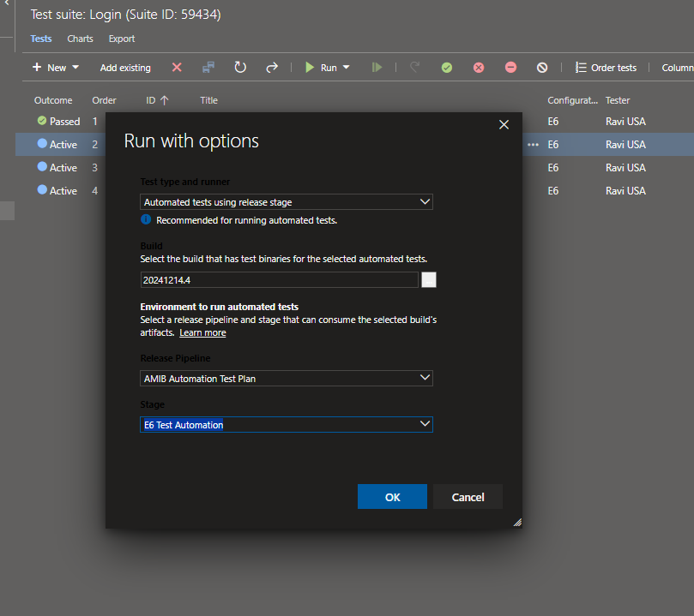

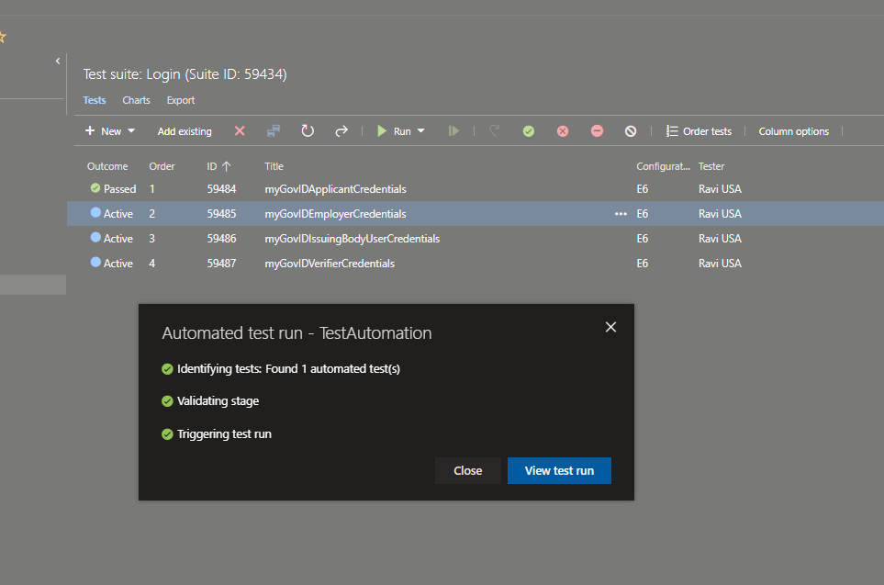

Second Option by directly selecting the test from the test plan and run for web application.

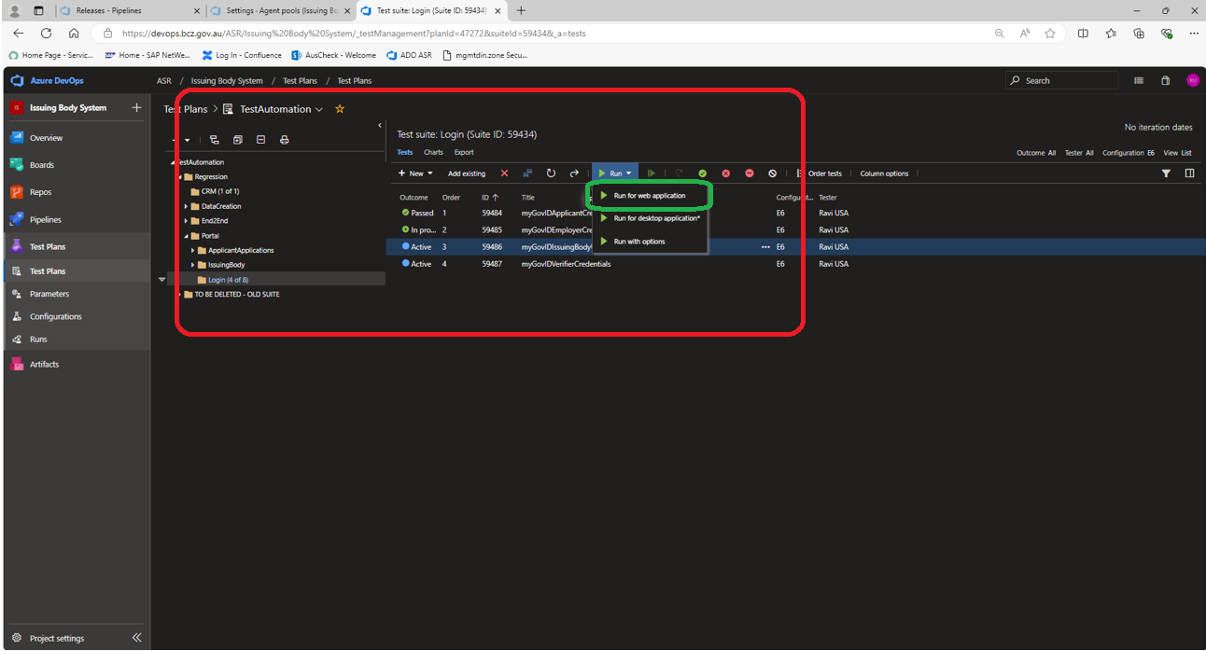

This will run the test directly in the test plan setting environment configured as follows. From the config shown below the test will be executed in e6 environment. The below screen can be access by right clicking on the TestAutomation test plan and selecting “Test Plan Settings” from the menu displayed.

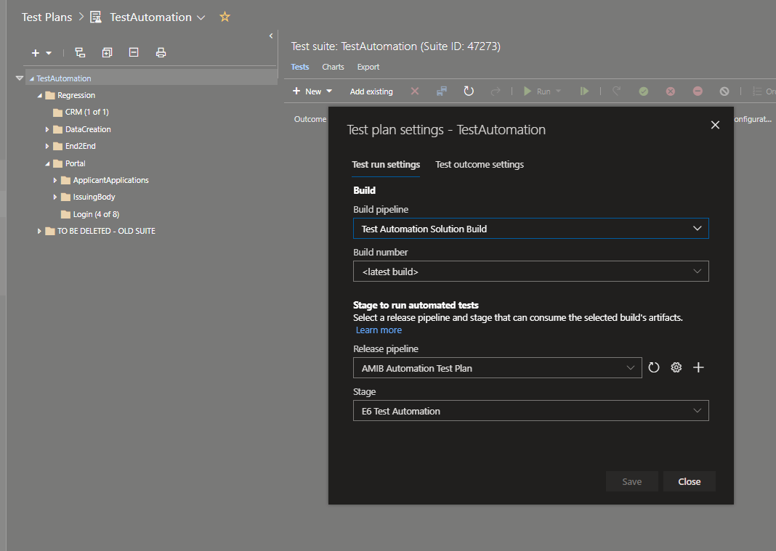

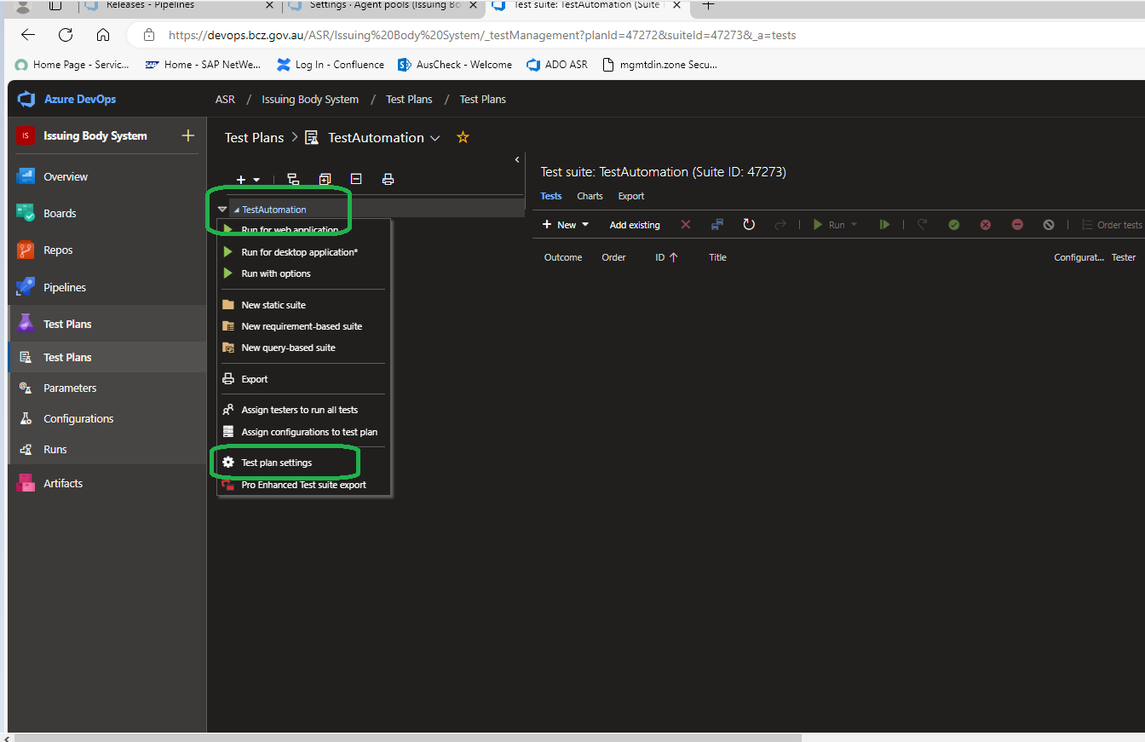

**AusCheck BCS Automation Test Hub Test Plan:**

Tests can be directly executed from Test Hub Test Plan as follows.

<https://devops.bcz.gov.au/ASR/Auscheck%20Redevelopment/_testManagement?planId=46961&suiteId=46962&_a=tests>

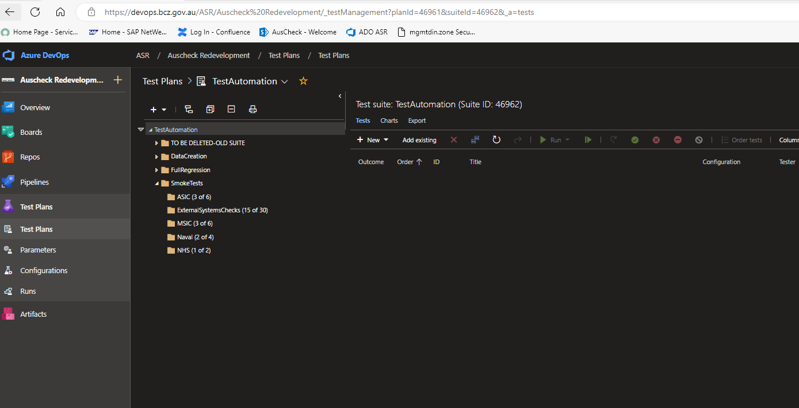

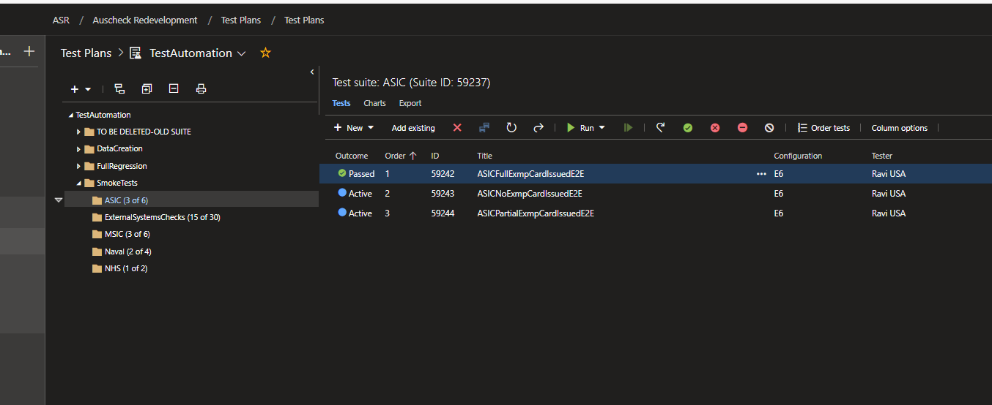

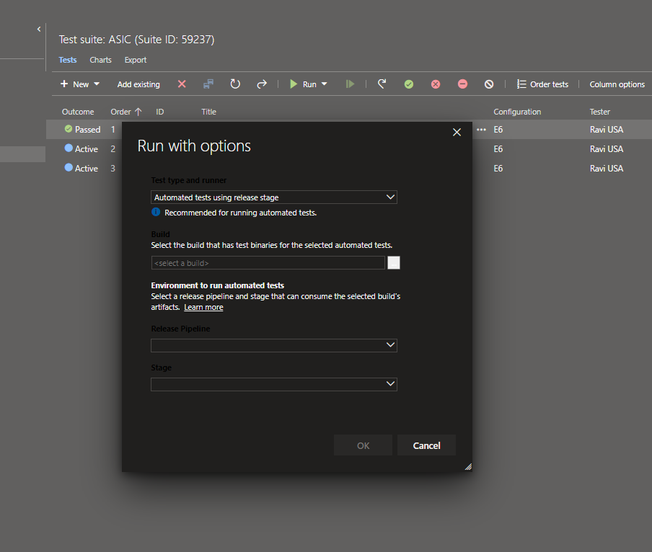

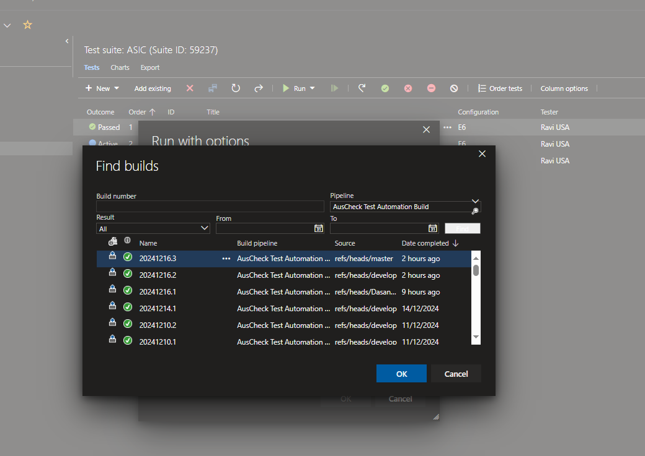

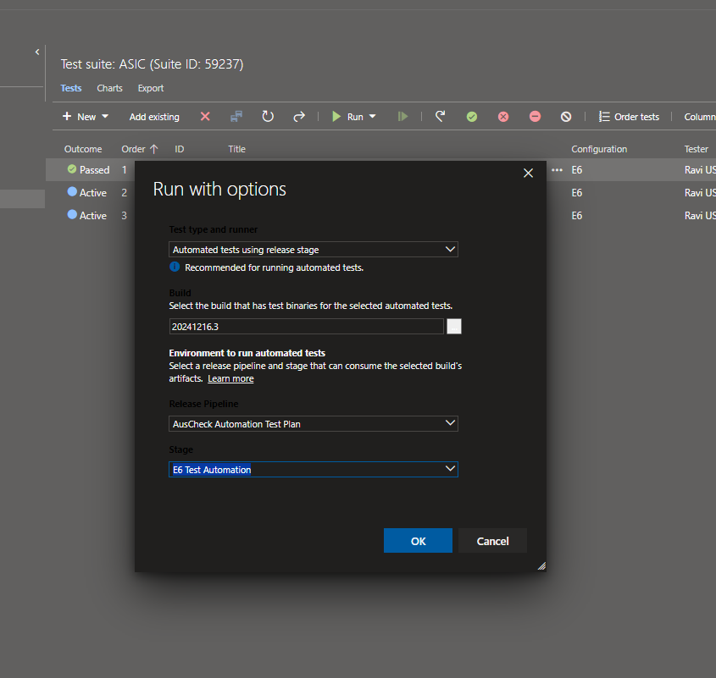

Second Option by directly selecting the test from the test plan and run for web application.

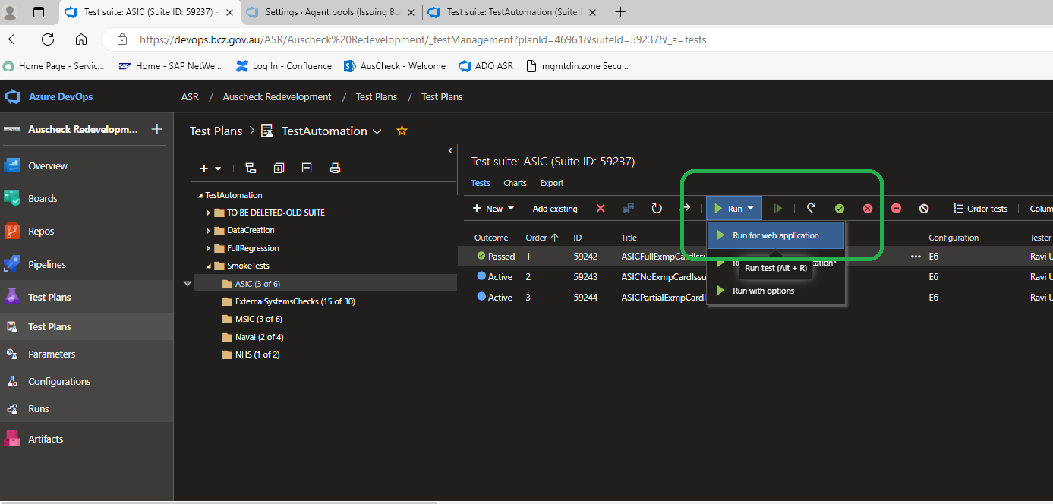

This will run the test directly in the test plan setting environment configured as follows. From the config shown below the test will be executed in e7 environment. The below screen can be access by right clicking on the TestAutomation test plan and selecting “Test Plan Settings” from the menu displayed.

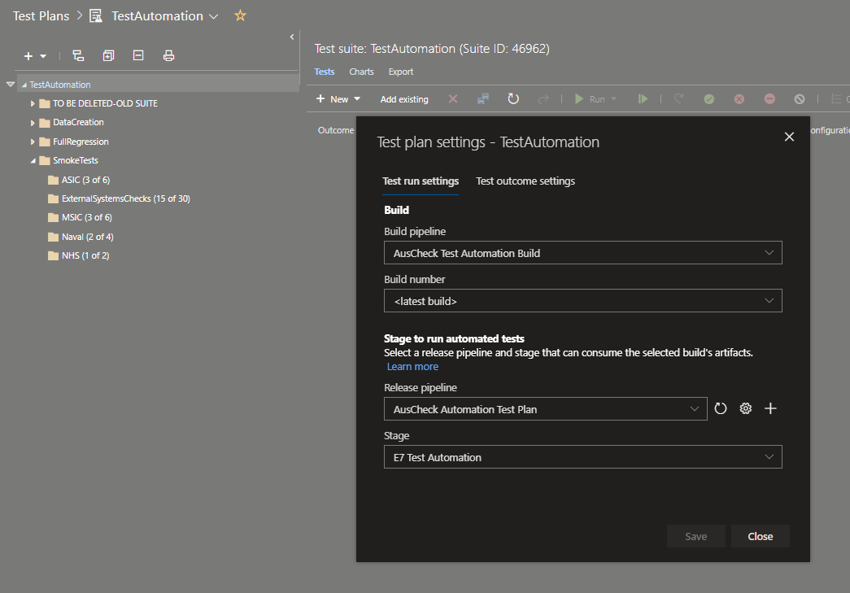

## Test Scenarios Implemented

### BCS

|  |  |
| --- | --- |
| **Automation Regression Test Details** | |
| **No** | **Test Name** |
| **AusCheckFunctionalTests.Tests.SmokeTests.ASIC** | |
| 1 | ASIC_NewApplication_PartialExemptionSubmissionAndCardIssued |
| 2 | ASIC_NewApplication_FullExemptionSubmissionAndCardIssued |
| 3 | ASIC_NewApplication_NoExemptionSubmissionAndCardIssuedE2E |
| **AusCheckFunctionalTests.Tests.SmokeTests.ExternalSystemsChecks** | |
| 4 | ASIC_NewApplication_NoExemptionAustralianVisa |
| 5 | ASIC_NewApplication_NoExemptionBirthCertificate |
| 6 | ASIC_NewApplication_NoExemptionCitizenship |
| 7 | ASIC_NewApplication_NoExemptionImmiCardDVSData |
| 8 | ASIC_NewApplication_NoExemptionRegistrationByDescent |
| 9 | ASIC_NewApplication_PartialExemptionPassport |
| 10 | ASIC_NewApplication_PartialExemptionChangeOfName |
| 11 | ASIC_NewApplication_PartialExemptionDL |
| 12 | ASIC_NewApplication_PartialExemptionAustralianMarriageCertificate |
| 13 | ASIC_NewApplication_PartialExemptionMedicareCard |
| 14 | ASIC_NewApplication_PartialExemptionMedicareCard |
| 15 | VerifyCrimHistoryCheckPopulateAndAutocompletes |
| 16 | VerifyCrimIntelCheckPopulateAndAutocompletes |
| 17 | VerifySecurityCheckPopulateAndAutocompletes |
| 18 | VerifyVEVOCheckPopulateAndAutocompletes |
| **AusCheckFunctionalTests.Tests.SmokeTests.MSIC** | |
| 19 | MSIC_NewApplication_PartialExemptionSubmissionAndCardIssued |
| 20 | MSIC_NewApplication_FullExemptionSubmissionAndCardIssued |
| 21 | MSIC_NewApplication_NoExemptionSubmissionAndCardIssued |
| **AusCheckFunctionalTests.Tests.SmokeTests.Naval** | |
| 22 | NSSIC_NewApplication_PartialExemptionSubmissionAndCardIssued |
| 23 | NSSIC_NewApplication_NoExemptionSubmissionAndCardIssuedE2E |
| **AusCheckFunctionalTests.Tests.SmokeTests.NHS** | |
| 24 | NHS_NewApplication_NoExemptionSubmissionAndCardStatusSetToNoCard_ |
| **AusCheckFunctionalTests.Tests.FullRegression.ApplicationWithdrawal.ASIC** | |
| 25 | ScenarioUserCannotWithdrawAnApplicationThatIsInACompletedStatus |
| 26 | ScenarioUserCanWithdrawAnApplicationThatIsInAnUncompletedStatus |
| 27 | ScenarioASICFullExemptionAddressSpecialCharacters_E2EFeature |
| **AusCheckFunctionalTests.Tests.FullRegression.ApplicationWithdrawal.MSIC** | |
| 28 | ScenarioUserCannotWithdrawAnApplicationThatIsInACompletedStatus |
| 29 | ScenarioUserCanWithdrawAnApplicationThatIsInAnUncompletedStatus |
| **AusCheckFunctionalTests.Tests.FullRegression.ApplicationWithdrawal.Naval** | |
| 30 | NewNSSICApplicationInAnUncompletedStatusCanBeWithdrawn |
| 31 | NewNSSICApplicationWithACompletedStatusCannotBeWithdrawn |
| **AusCheckFunctionalTests.Tests.FullRegression.CardActivities.NewASICE2ECardActivities** | |
| 32 | CancelCardForAnExistingSecurityCard |
| 33 | UserIsAbleToIssueAReplacementCardForACancelledCardFromADifferentIssuingBody |
| 34 | CardChangeStatusForAnExistingSecurityCard |
| 35 | ModifyCardForAnExistingSecurityCard |
| 36 | RenewalCardForAnExistingSecurityCard |
| 37 | ReplaceCardForAnExistingSecurityCard |
| 38 | TemporaryCardForAnIssuesStatusSecurityCardForTheSameIssuingBody |
| 39 | ASICToMSICCardActivityForAnExistingASICSecurityCard |
| 40 | UpdateVisaRenewalForAnExistingSecurityCard |
| **AusCheckFunctionalTests.Tests.FullRegression.CardActivities.NewMSICE2ECardActivities** | |
| 41 | CancelCardForAnExistingSecurityCard |
| 42 | UserIsAbleToIssueAReplacementCardForACancelledCardFromADifferentIssuingBody |
| 43 | MSICCardActivities_IndividualModificationE2E |
| 44 | CardChangeStatusForAnExistingSecurityCard |
| 45 | ModifyCardForAnExistingSecurityCard |
| 46 | RenewalCardForAnExistingSecurityCard |
| 47 | ReplaceCardForAnExistingSecurityCard |
| 48 | UpdateVisaRenewalForAnExistingSecurityCard |
| **AusCheckFunctionalTests.Tests.FullRegression.CardActivities.VerifyCard** | |
| 49 | ASICVerifyCardInPortal |
| 50 | MSICVerifyCardInPortal |
| **AusCheckFunctionalTests.Tests.FullRegression.E2EPORTALAndCRM.ASIC** | |
| 51 | ASIC_NewApplication_FullExemptionSubmissionAndCardIssued |
| 52 | ASIC_ModifyApplication_E2E |
| 53 | ASIC_NewApplication_NoExemptionSubmissionAndCardIssuedE2E |
| 54 | ASICOverseasTempCardIssued |
| 55 | ASIC_NewApplication_PartialExemptionSubmissionAndCardIssued |
| 56 | ASIC_RemediateDocuments_E2E |
| **AusCheckFunctionalTests.Tests.FullRegression.E2EPORTALAndCRM.CIBC** | |
| 57 | CriticalInfrasructure_NewApplication_FullExemptionSubmissionAndCardIssued |
| 58 | CriticalInfrasructure_NewApplication_NoExemptionSubmissionAndCardIssuedE2E |
| 59 | CriticalInfrasructure_NewApplication_NoExemptionSubmissionUnder18E2E |
| 60 | CriticalInfrasructure_NewApplication_PartialExemptionSubmissionAndCardIssued |
| **AusCheckFunctionalTests.Tests.FullRegression.E2EPORTALAndCRM.JobReady** | |
| 61 | ASIC_NewJobReadyApplication_NoExemptionSubmissionAndCardToBeIssued |
| 62 | MSIC_NewJobReadyApplication_NoExemptionSubmissionAndCardToBeIssued |
| **AusCheckFunctionalTests.Tests.FullRegression.E2EPORTALAndCRM.LAI** | |
| 63 | ASIC_NewApplicationForLAIApplicant_FullExemptionSubmissionAndCardIssued |
| 64 | ASIC_NewApplicationWithPhotoForLAIApplicant_FullExemptionSubmissionAndCardIssued |
| 65 | MSIC_NewApplicationforLAIApplicant_FullExemptionSubmissionAndCardIssued |
| 66 | MSIC_NewApplicationforWithPhotoForLAIApplicant_FullExemptionSubmissionAndCardIssued |
| **AusCheckFunctionalTests.Tests.FullRegression.E2EPORTALAndCRM.MSIC** | |
| 67 | MSIC_NewApplication_FullExemptionSubmissionAndCardIssued |
| 68 | MSIC_NewApplication_NoExemptionSubmissionAndCardIssued |
| 69 | MSIC_NewApplication_PartialExemptionSubmissionAndCardIssued |
| **AusCheckFunctionalTests.Tests.FullRegression.E2EPORTALAndCRM.Naval** | |
| 70 | NSSIC_NewApplication_NoExemptionSubmissionAndCardIssuedUnder18E2E |
| 71 | NewNSSICFullExemptionApplicationSubmissionDisplaysErrorAtConfirmationScreen |
| 72 | NSSIC_NewApplication_NoExemptionSubmissionAndCardIssuedE2E |
| 73 | NSSIC_NewApplication_PartialExemptionSubmissionAndCardIssued |
| **AusCheckFunctionalTests.Tests.FullRegression.E2EPORTALAndCRM.NHS** | |
| 74 | NHS_NewApplication_NoExemptionSubmissionAndCardStatusSetToNoCard_ |
| **AusCheckFunctionalTests.Tests.FullRegression.E2EPORTALAndCRM.NSSIC** | |
| 75 | NSSICNewApplication_BirthCertificateBasisOfOutcomeOthers |
| 76 | NSSICNewApplication_AustralianVISAVEVOOutcomeLawful |
| 77 | NSSICNewApplication_AustralianVISAVEVOOutcomeNoAuthorityToWork |
| 78 | NSSICNewApplication_AustralianVISAVEVOOutcomeNoMatch |
| **AusCheckFunctionalTests.Tests.FullRegression.E2EPORTALAndCRM.SelfReport** | |
| 79 | ASICIssuingBodySelfReportsOnApplicantsCourtConvictions |
| 80 | MSICIssuingBodySelfReportsOnApplicantsCourtConvictions |
| **AusCheckFunctionalTests.Tests.FullRegression.E2EPORTALAndCRM.Under18Applicants** | |
| 81 | ASIC_NewApplication_PartialExemptionSubmissionAndCardIssuedForUnder14Person |
| 82 | ASIC_NewApplication_PartialExemptionSubmissionAndCardIssuedForUnder18Person |
| 83 | NHS_NewApplication17AndAHalfApplicant_NoExemptionSubmissionAndCardStatusSetToNoCard_ |
| 84 | NewNSSIC17AndHalfYearsOldApplication |
| 85 | NewNSSICUnder14Application |
| **AusCheckFunctionalTests.Tests.FullRegression.E2EPORTALAndCRMOtherVariant.ASIC** | |
| 86 | ASIC_NewApplication_FullExemptionGreySubmissionAndCardIssued |
| 87 | ASIC_NewApplication_NoExemptionGreySubmissionAndCardIssuedE2E |
| 88 | ASIC_NewApplication_PartialExemptionSubmissionAndCardIssued |
| 89 | ASIC_NewApplication_FullExemptionWhiteCardIssued |
| 90 | ASIC_NewApplication_NoExemptionWhiteIbSubmissionAndCardIssuedE2E |
| 91 | ASIC_NewApplication_FullExemptionWhiteCardIssued |
| 92 | ASIC_NewApplication_NoExemptionWhiteUSCargoSubmissionAndCardIssuedE2E |
| **AusCheckFunctionalTests.Tests.FullRegression.E2EPORTALAndCRMOtherVariant.AutoApproval** | |
| 93 | VerifyApplicationIsNOTAutoCompletedForAnUnder18ApplicantThatHasPreviousApplicationsWithPendingAuscheckDecision |
| 94 | VerifyApplicationIsAutoCompletedForAnASICApplicantWithNoExemptionApplicationThatRequiresCrimIntelSecurityVEVOAndCrimHistoryChecks_ |
| 95 | VerifyApplicationIsNOTAutoCompletedForAnASICApplicantWithDcos |
| 96 | VerifyApplicationIsAutoCompletedForAnMSICApplicantWithNoExemptionApplicationThatRequiresCrimIntelSecurityVEVOAndCrimHistoryChecks_ |
| 97 | NewNSSICApplicationWithAllExternalChecksAutoApproved |
| 98 | VerifyApplicationIsAutoCompletedForAnUnder16ApplicantThatHasPreviousApplicationsWithPendingAuscheckDecision |
| 99 | VerifyApplicationIsAutoCompletedForAn17AndAHalfYearsOfAgeApplicant |
| **AusCheckFunctionalTests.Tests.FullRegression.E2EPORTALAndCRMOtherVariant.DriverLicense** | |
| 100 | ASIC_NewApplication_SubmitAnApplicationForAnApplicantFromAStateThatDoesNOTRequireTheLicenceCardNumber |
| 101 | ASIC_NewApplication_SubmitAnApplicationForAnApplicantFromAStateThatDoesRequireTheLicenceCardNumber |
| 102 | MSIC_NewApplication_SubmitAnApplicationForAnApplicantFromAStateThatDoesNOTRequireTheLicenceCardNumber |
| 103 | MSIC_NewApplication_SubmitAnApplicationForAnApplicantFromAStateThatDoesRequireTheLicenceCardNumber |
| **AusCheckFunctionalTests.Tests.FullRegression.E2EPORTALAndCRMOtherVariant.MATCHID** | |
| 104 | ApplicantWithMultipleNameChangesInThePastCanStillSubmitAnApplication |
| **AusCheckFunctionalTests.Tests.FullRegression.E2EPORTALAndCRMOtherVariant.MSIC** | |
| 105 | MSIC_NewApplication_FullExemptionSubmissionAndCardIssued |
| 106 | MSIC_NewApplication_NoExemptionSubmissionAndCardIssued |
| 107 | MSICBlue4_NewApplication_PartialExemptionSubmissionAndCardIssued |
| 108 | MSIC_NewApplication_FullExemptionWhite2SubmissionAndCardIssued |
| 109 | MSIC_NewApplication_NoExemptionWhite2SubmissionAndCardIssued |
| 110 | MSICWhite2_NewApplication_PartialExemptionSubmissionAndCardIssued |
| **AusCheckFunctionalTests.Tests.FullRegression.E2EPORTALAndCRMOtherVariant.PersonMerge** | |
| 111 | ASIC_NewApplication_FullExemptionSubmissionCardIssueForPersonThatHasMatchingDOBAndAddress |
| **AusCheckFunctionalTests.Tests.FullRegression.E2EPORTALAndCRMOtherVariant.VEVO** | |
| 112 | ASIC_NewVEVOApplication_PartialExemptionSubmissionAndCardIssued |
| 113 | MSIC_NewVEVOApplication_PartialExemptionSubmissionAndCardIssued |
| 114 | NHS_NewApplicationVEVOApplication |
| 115 | NSSIC_NewApplicationWithVevoCheck |
| **AusCheckFunctionalTests.Tests.FullRegression.LENS** | |
| 116 | LENS_ViewPersonReportAndVerifyPrintButton |
| 117 | LENS_ViewPersonReportAndVerifyCancelledCardInformation |
| 118 | LENS_ViewPersonReportAndVerifyNameHistory |
| **AusCheckFunctionalTests.Tests.FullRegression.NegativeTesting** | |
| 119 | ASIC_NewApplication_IDDOCDOBMismatchNegative |
| 120 | ASIC_NewApplication_FamilyNameMismatchNegative |
| 121 | ASIC_NewApplication_FamilyNameSpecialCharNegative |
| 122 | ASIC_NewApplication_GivenNameMismatchNegative |
| 123 | ASIC_NewApplication_IDDOCDOBMismatchNegative |
| **AusCheckFunctionalTests.Tests.FullRegression.PortalDashboards** | |
| 124 | ASICUserIsAbleToNavigateToTheMaintailDetailsPage |
| 125 | MSICUserIsAbleToNavigateToTheMaintailDetailsPage |
| **AusCheckFunctionalTests.Tests.FullRegression.PortalSearches** | |
| 126 | ApplicationSearch_VerifyApplicationSearchSuccessfulForAnExistingApplication |
| 127 | CardSearch_VerifyCardSearchSuccessfulForACancelledCard |
| 128 | CardSearch_VerifyCardSearchSuccessfulForAnExistingIssuedCard |
| 129 | PersonSearch_VerifyPersonSearchSuccessfulForAnExistingApplication |
| **AusCheckFunctionalTests.Tests.FullRegression.Z_BulkUpload** | |
| 130 | E2ENHS_BulkUploadAnApplicationActionItInCRMPortalAndIssueCard |
| 131 | E2EMSIC_BulkUploadAnApplicationActionItInCRMPortalAndIssueCard |
| 132 | E2EASIC_BulkUploadAnApplicationActionItInCRMPortalAndIssueCard |
| 133 | E2EASIC_BulkExcelUploadAPartialExemptionApplicationActionItInCRMPortalAndIssueCard |
| 134 | E2EASIC_BulkExcelUploadAPartialExemptionApplicationWithInternationalAddressActionItInCRMPortalAndIssueCard |
| 135 | E2EASIC_BulkExcelUploadANoExemptionApplicationActionItInCRMPortalAndIssueCard |
| 136 | E2ENHS_BulkExcelUploadAnApplicationActionItInCRMPortalAndIssueCard |
| 137 | E2EASIC_BulkExcelUploadAFullExemptionApplicationActionItInCRMPortalAndIssueCard |
| 138 | E2EMSIC_BulkExcelUploadAnApplicationActionItInCRMPortalAndIssueCard |
| 139 | E2EMSIC_BulkExcelUploadAnApplicationActionItInCRMPortalAndIssueCardInternationCountryState |
| 140 | E2EASIC_BulkExcelUpload100Applications |
| 141 | E2EMSIC_BulkExcelUpload100Applications |
| 142 | E2ENHS_BulkExcelUpload100Applications |
| 143 | UserBulkUploadsSeveralNewASICApplicationsUsingAnXmlUploadFeatureInPortal |
| 144 | UserBulkUploadsSeveralNewMSICApplicationsUsingAnXmlUploadFeatureInPortal |
| 145 | UserBulkUploadsSeveralNewNHSApplicationsUsingAnXmlUploadFeatureInPortal |
| 146 | ASICBulkExcelUploadImages |
| 147 | MSICBulkExcelUploadImages |
| 148 | NavalExcelBulkUpload |
| 149 | NavalXmlBulkUpload |
| **AusCheckFunctionalTests.Tests.DataCreation.ApplicationWithDCOs** | |
| 150 | NewASICNOExemptionApplicationWithDcosOnApplicantCompleteApplication |
| 151 | NewMSICPartialExemptionApplicationWithDcosOnApplicantCompleteApplication |
| 152 | CriticalInfrasructure_NewApplication_NoExemptionWithDcosOnApplicantCompleteApplication |
| 153 | NSSIC_NewApplication_PartialExemptionWithDcosOnApplicantCompleteApplication |

Additionally there are Test Data Creation Scripts as follows.

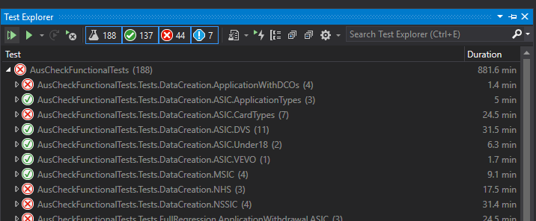

**BCS Scenarios Backlog (High-level Scope)**

* **Web-Services**
* **Biometrics – Auto Merge, Split and Combinations**
* **myGovID logins for e7 to speed up execution**
* **Photo tests**
* **Self report updates**
* **BPF Scenarios**
* **Email verification – Auto Correspondence**

Note: Please reach out to testing team (Prashanthi and Naresh) for more details of the above scenarios and prioritization of the above scenario implementation.

### AMIB

|  |  |
| --- | --- |
| **Automation Regression Test Details** | |
| **No** | **Test Name** |
| **Portal Logins** | |
| 1 | Applicant Login by myGovID |
| 2 | Employer Login by myGovID |
| 3 | Issuing Body User Login by myGovID |
| 4 | Verifier Login by myGovID |
| **Issuing Body Officer Search** | |
| 5 | Issuing Body Officer Applicant Search |
| 6 | Issuing Body Officer Employer Search |
| 7 | Issuing Body Officer Verifier Search |
| **Applicant Application [Employer Pays]** | |
| 8 | ASIC Applicant submits New Application with No Exemption |
| 9 | ASIC Applicant submits New Application with Full Exemption |
| 10 | ASIC Applicant submits New Application with Partial Exemption |
| 11 | MSIC Applicant submits New Application with No Exemption |
| 12 | MSIC Applicant submits New Application with Full Exemption |
| 13 | MSIC Applicant submits New Application with Partial Exemption |
| 14 | MSIC Applicant submits New Application Based in ASIC Application |
| 15 | CIBCO Applicant submits New Application with No Exemption |
| 16 | CIBCO Applicant submits New Application with Partial Exemption |
| 17 | NSSIC Applicant submits New Application with No Exemption |
| 18 | NSSIC Applicant submits New Application with Partial Exemption |
| 19 | ASSIC Applicant submits New Application Employer Pays Adding multiple facilities |
| 20 | GEP Defence Applicant Application Submission with No Exemption |
| 21 | GEP Non Defence Applicant Application Submission with No Exemption |
| **Applicant Application [Applicant Pays]** | |
| 22 | ASIC Applicant submits New Application with No Exemption pay via Credit Card |
| 23 | ASIC Applicant submits New Application with Partial Exemption pay via PayPal |
| 24 | MSIC Applicant submits New Application with Partial Exemption pay via Credit Card |
| 25 | MSIC Applicant submits New Application with No Exemption pay via PayPal |
| 26 | ASSIC Applicant submits New Application Applicant Pays Adding multiple facilities |
| **End To End [Employer Paid - New Application to Security Card Issue]** | |
| 27 | ASIC Applicant submits New Application with No Exemption To Security Card Issue |
| 28 | ASIC Applicant submits New Application with Full Exemption To Security Card Issue |
| 29 | ASIC Applicant submits New Application with Partial Exemption To Security Card Issue |
| 30 | MSIC Applicant submits New Application with No Exemption To Security Card Issue |
| 31 | MSIC Applicant submits New Application with Full Exemption To Security Card Issue |
| 32 | MSIC Applicant submits New Application with Partial Exemption To Security Card Issue |
| 33 | MSIC Applicant submits New Application Based in ASIC Application To Security Card Issue |
| 34 | CIBCO Applicant submits New Application with No Exemption To Security Card Issue |
| 35 | CIBCO Applicant submits New Application with Partial Exemption To Security Card Issue |
| 36 | NSSIC Applicant submits New Application with No Exemption To Security Card Issue |
| 37 | NSSIC Applicant submits New Application with Partial Exemption To Security Card Issue |
| 38 | ASIC Applicant submits New Application Employer Pays To AUS Wide Security Card Issue |
| 39 | ASIC Applicant submits New Application Applicant Pays To AUS Wide Security Card Issue |
| **End To End [Applicant Paid - New Application to Security Card Issue]** | |
| 40 | ASIC Applicant submits New Application with No Exemption pay via Credit Card To Security Card Issue |
| 41 | ASIC Applicant submits New Application with Partial Exemption pay via PayPal To Security Card Issue |
| 42 | MSIC Applicant submits New Application with Partial Exemption pay via Credit Card To Security Card Issue |
| 43 | MSIC Applicant submits New Application with No Exemption pay via PayPal To Security Card Issue |
| **End To End [Issuing Body Officer Applicant Application to Security Card Issue]** | |
| 44 | Issuing Body Officer Applicant New Application with No Exemption pay via Credit Card To Security Card Issue |
| **Card Replacements - End To End** | |
| 45 | Applicant Cancel Issued Lost Security Card to Issue new Security Card - Employer Pays |
| 46 | Applicant Cancel Issued Lost Security Card to Issue new Security Card - Applicant Pays |
| **OpNeed Upgrade - End To End** | |
| 47 | Upgrade Applicant OpNeeds to Issue new Security Card - Employer Pays |
| 48 | Upgrade Applicant OpNeeds to Issue new Security Card - Applicant Pays |
| **OpNeed Downgrade - End To End** | |
| 49 | Downgrade Applicant OpNeeds to Issue new Security Card - Employer Pays |
| 51 | Downgrade Applicant OpNeeds to Issue new Security Card - Applicant Pays |
| **Employer Remediations** | |
| 51 | Issuing body officer request employer remediation and employer completes remediation - Employer Pays |
| 52 | Issuing body officer request employer remediation and employer completes remediation - Applicant Pays |
| 53 | Action Employer remediation and Issuing Body officer approves manual review - Employer Pays |
| 54 | Action Employer remediation and Issuing Body officer approves manual review - Applicant Pays |
| **Applicant Remediations** | |
| 55 | Issuing Body officer request applicant photo remediation request - Employer Pays |
| 56 | Issuing Body officer request applicant photo remediation request - Applicant Pays |
| 57 | Applicant action targetted photo remediation and Issuing Body officer approves manual review - Employer Pays |
| 58 | Applicant action targetted photo remediation and Issuing Body officer approves manual review - Applicant Pays |
| 59 | Issuing Body officer request applicant document remediation request - Employer Pays |
| 60 | Issuing Body officer request applicant document remediation request - Applicant Pays |
| 61 | Applicant action targetted document remediation and Issuing Body officer approves manual review - Employer Pays |
| 62 | Applicant action targetted document remediation and Issuing Body officer approves manual review - Applicant Pays |
| 63 | Issuing Body officer request applicant full application remediation request - Employer Pays |
| 64 | Issuing Body officer request applicant full application remediation request - Applicant Pays |
| **GEP Applications** | |
| 65 | GEP Defence Applicant Application Submission with No Exemption to completion |
| 66 | GEP Non Defence Applicant Application Submission with No Exemption to completion |

**AMIB Scenarios Backlog (High-level Scope)**

* **CIBC and NSSIC – Additional OpNeeds**
* **Naval – Negative crim history**
* **Card Replacement Faulty Card (Employer and Applicant Pays)**
* **Operational Need Downgrade – MSIC, White card, Naval, CIBC (Employer and Applicant Pays including Email verifications)**
* **Under 18 Application End to End**
* **Facility Management – FO admin, FO users and Employer-Facility**
* **IB officer MSIC paper based application**
* **Few negative outcome scenarios**
* **IB Officer acting as employer and verifier**
* **VEVO applications**
* **Emulating Device testing using screen resolution (Browser Dev Tools)**

Note: Please reach out to testing team (Sirisha and Naresh) for more details of the above scenarios and prioritization of the above scenario implementation.

## Reporting

AusCheck BCS and AMIB test manager and Scrum master expects Test Automation signoff and reflect all passed test scenarios and any known issues for release to happen as planned.

Attaching Release 4.8 results shared for both AusCheck BCS and AMIB tests with the Scrum master for reference.



Note: Please check with Naresh (Test Manager) for more details.

Appendix

**VM Machine Details:**

At the time of writing this documents these are machines which are used for test automation execution and development.

Note: TWS Admin team have notified that going forward existing TWS VM machines will not be supported by their team and requested to log new “Server Build Service Request” from connected services and liaise with Brady SCHOO and Naresh for Next steps.

**PDCWNBVSP224.dinnp.bcz.gov.au**

**PDCWNBVSP227.dinnp.bcz.gov.au**

**PDCWNBVSP242.dinnp.bcz.gov.au**

**PDCWNBVSP252.dinnp.bcz.gov.au**

**FDCWNBVSP211.dinnp.bcz.gov.au** (Configured for Dedicated Build Pipeline)

**Symantec Antivirus Protection:**

All VM machines have Symantec Antivirus Protection enabled. This will hinder running any exe files, git command, and even does allow Selenium webdriver to run the tests.

You can disable the antivirus protection for development and test execution purposes as follows.

* Open command line and type “SISIPSOVERRIDE”

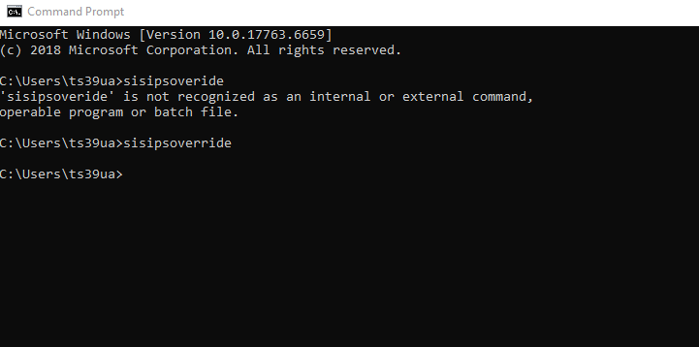

* The above command opens the following windows

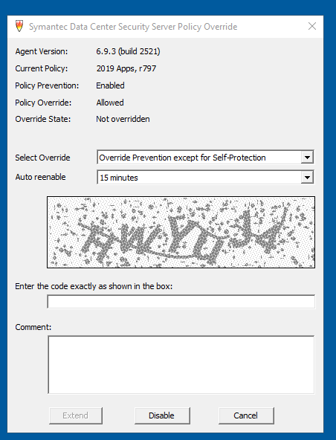

* Change the Auto reenable dropdown value to 48 hts (max allowed value) and then enter the code (tip: code is case insensitive), add comments and then click disable.

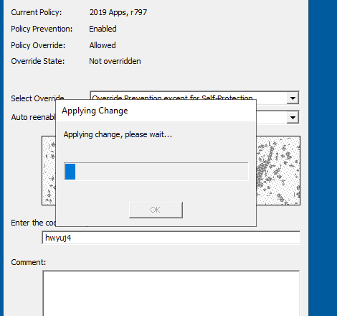

* Once the changes are applied it will disable the protection and machine can be used for test execution etc.,

